Section II - Inventory

List of Tables:
Table 2-1: LWRP Population 9
Table 2-2:Houshold Median Income 11
Table 2- 3: 2022 Poverty Rate 12
Table 2-4: Educational Attainment 13
Table 2-5: Land Use Distribution 24
Table 2-6: Zoning Distribution 26
Table 2-7: Soils 45
Table 2-8: Bird Species 54
Table 2-9: Rare or Endangered Species 54
Table 2-10: Invasive Species 55
Table 2-11: Natural Register of Historic Places 61

List of Figures:
Figure 2-1: Downtown Elmira Early 20th Century 5
Figure 2-2: View of Downtown Elmira Following 1972 Flood 6
Figure 2-3: Elmira and Chemung County Population 7
Figure 2-4: Regional Population Loss 8
Figure 2-5: City of Elmira Age Distribution 11
Figure 2-6: Elmira and Chemung County Household Median Income 12
Figure 2-7: Elmira Race Distribution 2010-2020 13
Figure 2-8: City of Elmira Unemployment Rate 2000-2020 16
Figure 2-9: City of Elmira Major Industries 2000-2020 17
Figure 2-10: Zoning Table 26
Figure 2-11: Elmira Water Sources 35

List of Maps:
Map 2-1: Census Block Group (2020) 9
Map 2-2: Environmental Justice Populations 18
Map 2-3: Transportation 20
Map 2-4: Public Services and Infrastructure 23
Map 2-5: Existing Land Use 27
Map 2-6: Existing Zoning 32
Map 2-7: Active Industrial Sites 34
Map 2-8: Underutilized and Vacant Sites 38
Map 2-9: Water Dependent and Enhanced Uses 41
Map 2-10: Land Ownership 43
Map 2-11: Underwater Lands 44
Map 12: Chase-Hibbard Dam 46
Map 2-13: Remediation Sites 49
Map 2-14: Topography 51
Map 2-15: Hydric Soils 53
Map 2-16: Soils 54
Map 2-17: Surface Geology 55
Map 2-18: Watersheds 58
Map 2-19: Wetlands 59
Map 2-20: Sensitive Environmental Features 60
Map 2-21: Floodplains 64
Map 2-22: Flood Protection 65
Map 2-23: Historic and Cultural Features 70
Map 2-24: Scenic Resources 72
Map 2-25 - Tourism Resources 73
Map 2-26: Park and Recreation 75
Map 2-27: SHPO Archaeological Buffer Areas 77

Appendices:
Appendix A: Underutilized and Deteriorated Sites
Appendix B: Vacant Sites
Appendix C: NYSDEC Remediation Sites

2.1 Community Profile

A. Regional Geographic Setting
The Local Waterfront Revitalization Program (LWRP) Waterfront Revitalization Area (WRA) is located in the City of Elmira, New York. Elmira is located centrally in Chemung County along the Chemung branch of the Susquehanna River, more commonly known as the Chemung River. The city is within New York’s Southern Tier, a region along the New York State / Pennsylvania border stretching from Delaware County in the east to Chautauqua County in the west. Elmira is the third largest city in the region, behind Binghamton and Ithaca. As such, Elmira is an important economic hub for the western portion of the region, alongside Corning, which shares a combined statistical area (CSA) with Elmira. The community is located centrally in New York State, within 3 hours drive of Western and Central New York’s four largest cities of Buffalo, Rochester, Albany, and Syracuse, and 4 hours from New York City.

B. Community and Waterfront Development History

Early History
The evidence of the earliest Native American settlements in Chemung County date back to 800 A.D. The region was inhabited mostly by the Algonquin, Seneca, and Delaware people until the 18th century. The first Western settlements along the Chemung River were in the modern-day Town of Chemung, located southeast of Downtown Elmira. In 1792, a new village was founded at the confluence of the Chemung River and Newtown Creek, which is now known as the City of Elmira. This village grew mostly from industries centered around the Chemung River and Newtown Creek, much of this early development taking place in the WRA along Water, Main, and Church Streets. Early developments included mills and the development of multiple weirs and small dams to control the flow of the river.
The Chemung River was a vital resource to Chemung County’s early economy. The river’s quick flow and many rapids and changes in elevation made navigation difficult but provided an excellent source of mechanical power for mills and other industry. Elmira and other towns along the river quickly developed and began to increase in population. Elmira later became a hub for trade and transportation, with highways, railroads, and canals connecting Elmira and Rochester, Buffalo, and Southern Pennsylvania.
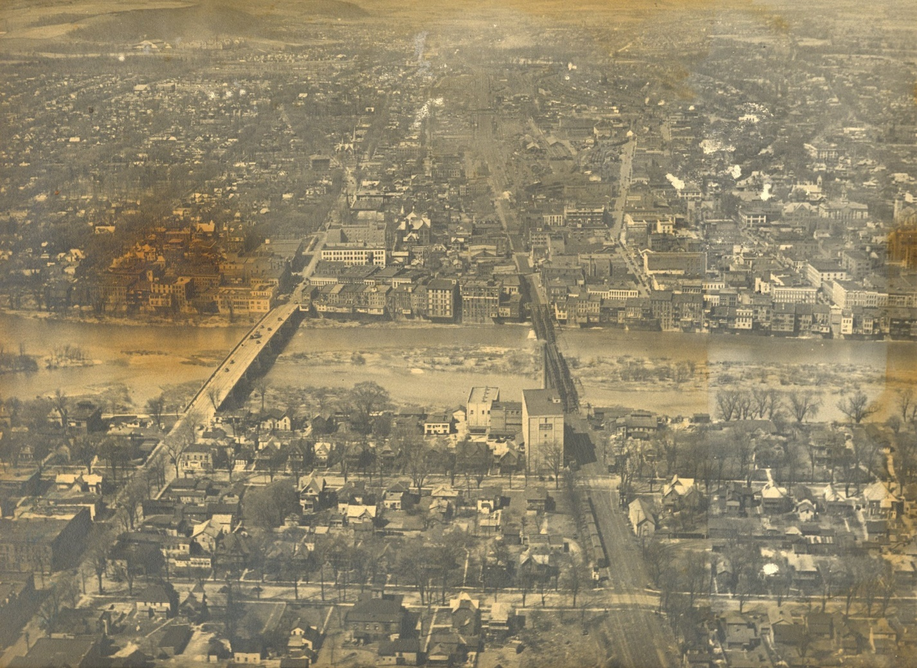
Figure 2-1: Downtown Elmira Early 20th Century
Courtesy of the Chemung County History Museum

1972 Flood
In 1972, a devastating flood struck much of the community. Many bridges, homes, and businesses were destroyed, though there was miraculously no loss of life. If a similar flood were to occur today, damages to bridges, buildings, and other infrastructure would be estimated to exceed $2 billion according to an article published by the Star Tribune. The Chemung River, which had been the key to the success of Elmira, effectively destroyed the town, leaving residents across the region to dig out and rebuild.
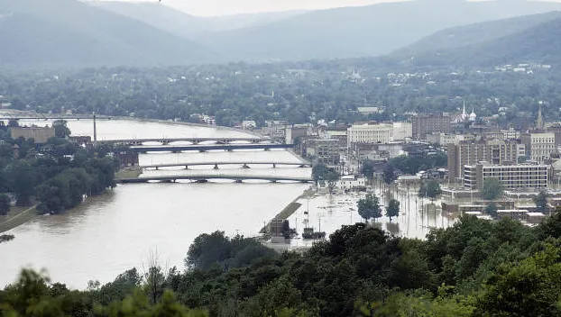
Figure 2-2: View of Downtown Elmira Following 1972 Flood
Source: Cooper, Ken. (1972).

Urban Renewal to today
The 1972 flood jumpstarted many urban renewal efforts along the Chemung River waterfront in both Elmira and nearby Corning. Because of the severe damage from the flood, many blocks in the most severely affected areas, including much of the current WRA, were demolished, with plans to replace the development with more flood-resistant uses such as parks or parking lots. As a result, over 40% of the commercial space in Elmira was lost, creating lasting economic impacts, many of which are still experienced by the community today.
Much of the recent history of Elmira’s waterfront has been defined by decline and demolition, a challenge faced by many cities within the region and Upstate New York. In the 1970s until recently, much of the WRA was framed by loss of industry, population, and the city’s historic building fabric. However, in the last decade, economic development efforts have resulted in key initiatives and projects in the waterfront area, This includes new and enhanced public spaces and parks, job growth and creation, and new development, such as historic reuse and restoration projects on the 300 block of E Water Street and 100 West Water Street Apartments. This new development has placed Elmira in a position to plan for growth downtown and on the waterfront in a way that respects the historical character of its past and the importance of the Chemung River. While this new development is encouraging, flood protective infrastructure including the flood walls and levee have remained a challenge and act as a barrier to public access along the Chemung River and Newtown Creek. This barrier limits public access and enjoyment, and a key goal of the LWRP is to increase the number and quality of public access points to unleash Elmira’s waterfront potential.

C. Population and Demographics

Population Trends
Elmira is the main population center of Chemung County, with a population of 26,523 according to the 2020 census. Both the City of Elmira and Chemung County have experienced a steady population loss since peaking in the post-war era (see Figure 2-3: Elmira and Chemung County Population). Elmira’s population peaked around 1950, with a population of 49,716, and has experienced a steady 43% loss in population in the last 70 years. While Chemung County’s population reached its highest levels in 1970, two decades after the City of Elmira’s, the population of surrounding towns and villages rose until around 2010, only showing a decline in the last decennial census of 2020, likely due to an aging population and outmigration to other areas of New York State and the United States. In 1950, when the city had its highest recorded population, the surrounding towns and villages accounted for 37,111 people, or 42.7% of the total county population. Today, the surrounding towns and villages have a population of 67,629, 71.8% of the county’s total population, suggesting a net migration out of the city to the suburban towns and villages in Chemung County. Impacts on workforce from these populations changes are further detailed in Section 2.1 D: Economic Profile.

Figure 2-3: Elmira and Chemung County Population
Source: US Census Bureau, 1900-2020 Decennial Census
This population loss is characteristic of many cities in the region, including Elmira’s peer cities of Corning in neighboring Steuben County and Binghamton in Broome County (See Figure 2-4: Regional Population Loss). Corning and Binghamton’s populations both peaked around 1950, the same decade as Elmira, with a 40.3% loss of population and 40.5% loss of population over the past 70 years, respectively. While Corning continues to lose population, much like Elmira, Binghamton was able to stem population loss in the early 2000s and has seen a small increase in population between the 2010 and 2020 census.
This population loss can be attributed to multiple factors, including the rapid suburbanization that occurred throughout New York State and the country after World War II resulting in net migration out of the city and region and deindustrialization that created a sluggish economy and below average job growth. This population loss has left the city struggling economically, along with aging infrastructure that is difficult to maintain with shrinking resources.

Figure 2-4: Regional Population Loss
Source: US Census Bureau, 1900-2020 Decennial Census
Despite population loss in the City of Elmira and Chemung County, the WRA has seen modest growth between 2000 and 2020 (See Table 2-1: LWRP Population). Much of this growth is centered around the historical central business district (Census Tract 6, Block Groups 2 and 3) which primarily developed in the mid 1800s ,as recent developments have introduced apartments in neighborhoods that were previously primarily office and commercial spaces. However, growth stagnated between 2010 and 2020, with most census block groups showing a loss of population. This fluctuation shows both the successes of targeted redevelopment and revitalization in the WRA and the need for additional efforts to stabilize and reverse population decline throughout the WRA, not just the central business district.

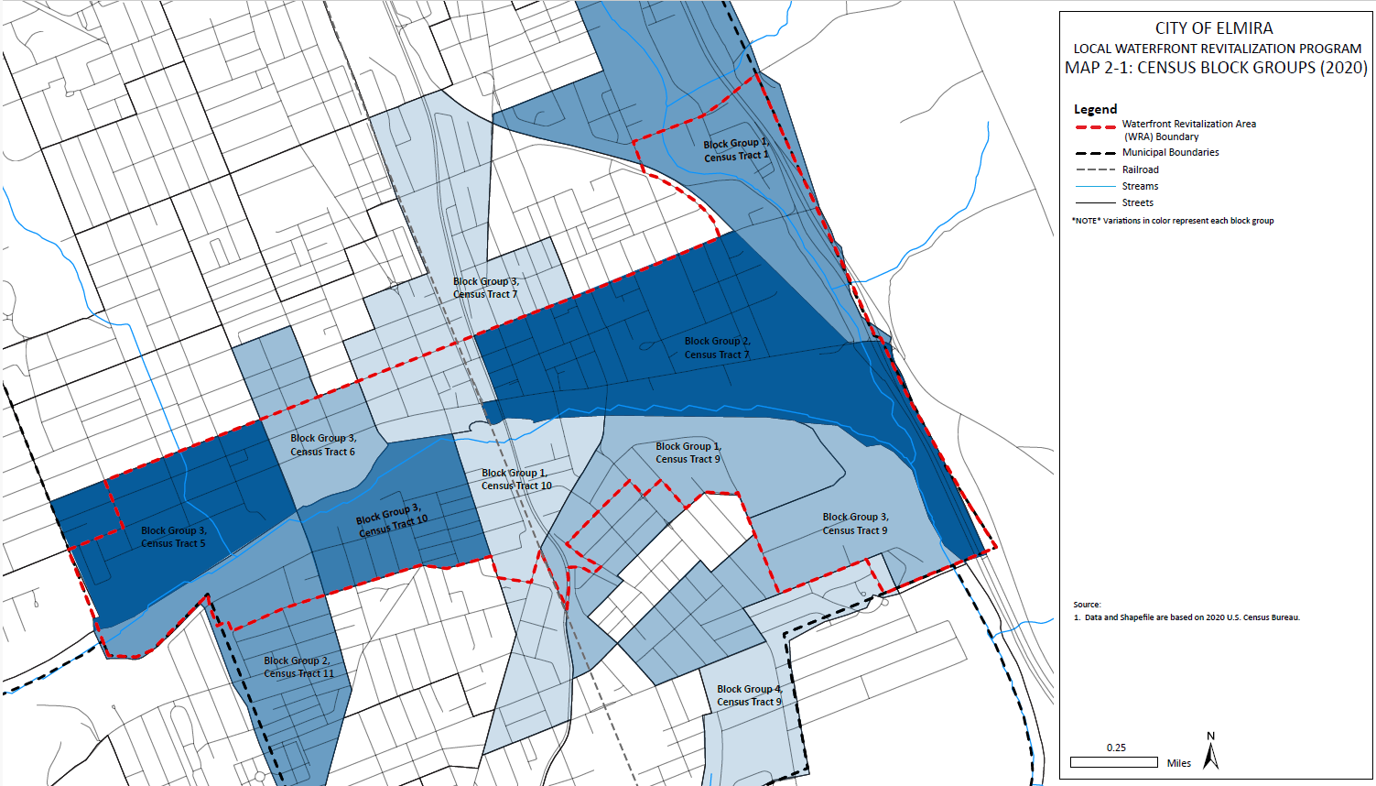
Map 2-1: Census Block Group (2020)
Table 2-1: LWRP Population
 | Population |  |  | Change 2000-2020
 | 2000 | 2010 | 2020 | Number | Percent
Chemung County | 91070 | 88830 | 84148 | -6922 | -8%
Elmira | 30940 | 29200 | 26523 | -4417 | -14%
LWRP Block Groups
Tract 1, Block Group 1 | 960 | 943 | 854 | -106 | -11%
Tract 5, Block Group 3 | 1233 | 1228 | 1164 | -69 | -6%
Tract 6, Block Group 2 | 1407 | 1352 | 1104 | -303 | -22%
Tract 6, Block Group 3 | 955 | 884 | 780 | -175 | -18%
Tract 7, Block Group 2 | 14 | 385 | 1223 | 1209 | 8636%
Tract 7, Block Group 3 | 174 | 793 | 595 | 421 | 242%
Tract 7, Block Group 4 | 104 | 563 | 0 | -104 | -100%
Tract 9, Block Group 1 | 1009 | 955 | 769 | -240 | -24%
Tract 9, Block Group 2 | 726 | 684 | 649 | -77 | -11%
Tract 9, Block Group 3 | 899 | 871 | 787 | -112 | -12%
Tract 10, Block Group 1 | 720 | 671 | 648 | -72 | -10%
Tract 10, Block Group 3 | 1147 | 1023 | 1043 | -104 | -9%
Tract 11, Block Group 2 | 478 | 914 | 888 | 410 | 86%
LWRP Total | 9826 | 11266 | 10504 | 678 | 7%
Source: US Census Bureau, 2000-2020 Decennial Census

Age
On average, the City of Elmira’s population is younger when compared to Chemung County and the State of New York. In the 2020 Census, the median age in the City of Elmira was 35.9 years, below New York State’s median age of 40 and Chemung County’s median age of 43. Only 14.8% of Elmira’s population was 65 or older, compared to 21% in Chemung County and 18.1% in New York State. However, Elmira is getting older, with a median age of 34, and 12.5% of the population over the age of 65. The number of children under 5 in Elmira also decreased between 2010 and 2020, from 6.8% in 2010 to 5.5% in 2020.

Figure 2-5: City of Elmira Age Distribution
Understanding the distribution of ages allows the City of Elmira to plan for the future more effectively. Even as the city is aging, there is a general distribution of ages, meaning Elmira must plan for the needs of all age groups. For older populations, this can include increased accessibility and access to outdoor amenities. Younger populations, especially families with children, need access to schools, parks, and playgrounds. Due to decreasing populations of young children in Elmira, there is a possibility that the number of existing amenities are sufficient and can be enhanced to serve existing populations.

Income
Elmira has, on average, a much lower income than the rest of Chemung County and New York State. In 2020, the median household income was $36,543, 49% lower than the State’s median household income of $71,117 and 33% lower than Chemung County’s median household income of $54,883.

Table 2-2:Houshold Median Income
Year | 2000 | 2010 | 2020
Elmira | $27,292 | $31,724 | $36,543
Chemung County | $36,415 | $47,643 | $54,883
New York State | $43,393 | $54,148 | $71,117
Source: US Census Bureau, 2000-2020 Decennial Census
Linear projections using income data from 2000 to 2020 were used to understand the rate of increase for incomes in Chemung County and the City of Elmira. These rates were used to create an estimated projected income in 2030, if increases in income are consistent with data since 2000. While the median household income for the City of Elmira has increased since 2000, the rate of increase is lower than Chemung County. If the increase in household median income increases at its current rate, Chemung County’s median income is projected to be $64,818 by 2030. Elmira’s household median income is projected to be $41,104 by 2030, 36% lower than the County’s median income. However, the 2022 American Community Survey indicated that this trend may not continue. Chemung County’s income was $55,845, 3% lower than projected as indicated in the chart below, while Elmira’s income was $41,072, or 10% higher than projected.

Figure 2-6: Elmira and Chemung County Household Median Income
Source: US Census Bureau, 2000-2020 Decennial Census
According to census data, 27.6% of all people in Elmira live in poverty, almost twice the State’s poverty rate of 14.3% and the county’s poverty rate of 15.8%. 38.6% of all children in the City of Elmira live in poverty, compared with 23% of all children in Chemung County in poverty. This, combined with the lower household median income in Elmira as indicated in the chart above, points to a concentration of poverty within the City of Elmira, particularly among populations under the age of 18. Populations experiencing poverty are less mobile and therefore rely more heavily on nearby access to the waterfront. This access, however, is lacking throughout the WRA and is further explored in Section 2.3: Existing Land and Water Use.
Table 2- 3: 2022 Poverty Rate
 | Poverty Rate | Childhood Poverty Rate
Elmira | 27.6% | 38.6%
Chemung County | 15.8% | 23.0%
New York State | 14.3% | 18.8%

Source: US Census Bureau, ACS 5-Year Estimates, 2018-2022

Race and Ethnicity
In the 2020 Census, the largest racial groups in Elmira were White and Black or African American. 72% of the population of Elmira identified their race as White in 2020, and 15% of the population identified their race as Black or African American. Since the 2010 census, Elmira has become increasingly diverse.
Overall, most racial groups saw a decrease in population. For instance, the percentage of the population that identified as White decreased from 78% in 2010 to 72% in 2020. The decrease across several groups was mostly accounted for by the percentage of the population that identified as one or more race, which increased from 5% in 2010 to 10% in 2020, and Asian which increased from 1% in 2010 to 2% of the total population in 2020. The percentage of the population that identified as Black or African American was 15% in both 2010 and 2020.

Figure 2-7: Elmira Race Distribution 2010-2020
Source: US Census Bureau, 2010 and 2020 Decennial Census
The largest ethnic group in the City of Elmira is Irish, with 15.6% of the population having Irish ancestry, followed by German at 13.9% and Italian at 11.8%. Only 2.5% of Elmira’s population was foreign born in 2020, well below the New York State average of 22.7%. Similarly, the primary language spoken in the City of Elmira in 2020 was English, with 95.1% of the population speaking English as their only language.

Education
The City of Elmira is primarily served by the City of Elmira School District. Within the City’s public school system, there are four elementary schools (Kindergarten through 2nd grade), four intermediate schools (grades 3-6), and three secondary schools (grades 7-12). Additional options for K-6 education is provided by the Finn Academy, a charter school located in the City of Elmira. Notre Dame High School provides private education for grades 7-12, also located in the City of Elmira.
There are two higher education facilities in the City of Elmira: Elmira College and the Lake Erie College of Medicine (LECOM). Elmira College is the largest higher education facility in the County. There is no community college in Chemung County, though the county is served by Corning Community College in Stueben County. In recent years, Chemung County and other partners have increased access to workforce training initiatives to provide continuing education, job training for specific roles as identified by the major employers in the county and providing an easier transition for those who may have lost their employment position. Some examples include the County’s Learn and Earn Program and Corning Community College’s Office of Workforce Development and Community Education, and Chemung-Schuyler-Steuben Workforce New York (CSSWFNY).
The City of Elmira has lower educational degree attainment compared to the rest of Chemung County and New York State. 79.6% of residents have graduated high school, with 36.1% having at least a high school degree. Only 16.4% of City of Elmira residents have a bachelor’s degree or higher, compared to 23.9% in Chemung County, and 38.1% in New York State.
Table 2-4: Educational Attainment
 | Less than High School Graduate | High School Graduate | Some College or Associate’s Degree | Bachelor’s Degree | Graduate Degree
Elmira | 19.4% | 36.1% | 27.1% | 9.0% | 7.4%
Chemung County | 10.5% | 34.3% | 31.2% | 12.9% | 11.0%
New York State | 12.6% | 25.2% | 24.1% | 21.3% | 16.8%
Source: US Census Bureau, ACS 5-Year Estimates, 2017-2021

D. Economic Profile

Business and Industry
Elmira is home to a variety of businesses, including anchor employers Howell Packaging and Arnot Health, the county’s largest employer. Outside the City of Elmira, several large employers provide jobs to the region including Elmira residents. North of the City of Elmira, Elmira Heights is home to many of the region’s largest employers, including Anchor Glass Container Corporation, CAF USA, and Hardinge Corporation. Further north, Horseheads has a variety of manufacturing and retail centers, thanks to its location close to the region’s airport and the HOST Business Park. Big Flats is the region’s retail hub, serving all of Chemung County, Steuben County, and Schuyler County. Big Flats is also home to the County’s airport and some of its largest manufacturing employers, including a manufacturing facility for Corning Inc. The Town of Chemung, south of the City of Elmira near the Pennsylvania border, has seen growth as well, including the construction of a new 750,000 square foot warehouse for CVS Caremark Corporation.
Corning, located to the west of Elmira in Steuben County, is home to Corning Industries, one of the largest employers in the region. The company is best known for its glass manufacturing but includes a variety of technologies from fiberoptics to healthcare technologies. While a variety of the manufacturing uses are located outside of the region and the country, the company still has a large presence in the community, with its headquarters and research and development center located in Corning. The Corning Museum of Glass, which was founded and is currently supported by the company, has helped to support a variety of other businesses in the region, including retail and tourism.
There are a variety of large employers within the WRA. Kennedy Valve and Howell Packaging are two major industrial operations, both of which have facilities in close proximity to the Chemung River. Additional large private employers include the Chemung Canal Trust Company, whose 6-story headquarters on Water Street is a prominent feature in the WRA. Community Bank at 333 E Water Street and 300 W Water Street also have a prominent presence in the WRA. A variety of retail, office, and medical services are located throughout the WRA, particularly in the central business district. Along Lake Street, the center for Chemung County’s government contains a sizable workforce, including the county’s administrative buildings, courts, and sheriff’s office. Three large health facilities, St. Joseph’s Hospital, the Chemung County Department of Health, and the Elmira Psychiatric Center, are clustered between Church Street and Water Street, east of Madison Avenue. As such, the WRA is particularly reliant on three industries – Education, Health and Social Services; Manufacturing; Public Administration; and Finance, Insurance, Real Estate and Rental Leasing.
Like the population of Elmira, the total workforce has steadily declined since 2000 from 13,263 employees in 2000 to 11,686 employees in 2020. During the same period, the unemployment rate decreased from 12.7% in 2000 to 8.9% in 2020 - however, employment statistics from January 2024 show the unemployment rate lower in the City of Elmira at 6%. Even with fewer workers in the workforce, the unemployment rate has fallen faster than the rate of total workers.

Figure 2-8: City of Elmira Unemployment Rate 2000-2020
Source: US Census Bureau, 2000-2020 Decennial Census
In 2020, the largest industry clusters in Elmira were education, healthcare, and social services, with Arnot Health as the largest employer in the city and in Chemung County, though this industry cluster has seen the largest decline in number of City residents employed between 2010 and 2020, a trend reflected across the country. This may be due to the consolidation of St. Joseph’s hospital with Arnot Health (now Centralus Health) in 2011. Other industries that have seen a decline in city residents employed include professional and administrative services; transportation and utilities; and agriculture. These declines closely mimic population loss. Manufacturing has seen the largest increase in the number of city residents employed, likely assisted by efforts from the City and County to increase workforce training and attract and grow manufacturing jobs in the region.
It is important to note that this data is representative of the population of Elmira, and not job opportunities located in the City of Elmira. It is likely that many of these jobs may be in neighboring towns and villages, and that jobs offered within the city employ residents of the surrounding towns and villages.

Figure 2-9: City of Elmira Major Industries 2000-2020

E. Environmental Justice Populations
Environmental Justice (EJ) is the fair and meaningful treatment of all people, regardless of race, income, national origin or color, with respect to the development, implementation, and enforcement of environmental laws, regulations and policies. Environmental Justice allows for disproportionately impacted residents to access the tools to address environmental concerns across all of the New York State Department of Environmental Conservation’s (NYSDEC) operations. In spring 2023, New York Governor Kathy Hochul signed the strongest environmental justice law in the country, which provides that the NYSDEC “shall not issue an applicable permit for a new project if it determines that the project will cause or contribute more than a de minimis amount of pollution to a disproportionate pollution burden on the disadvantaged community.”

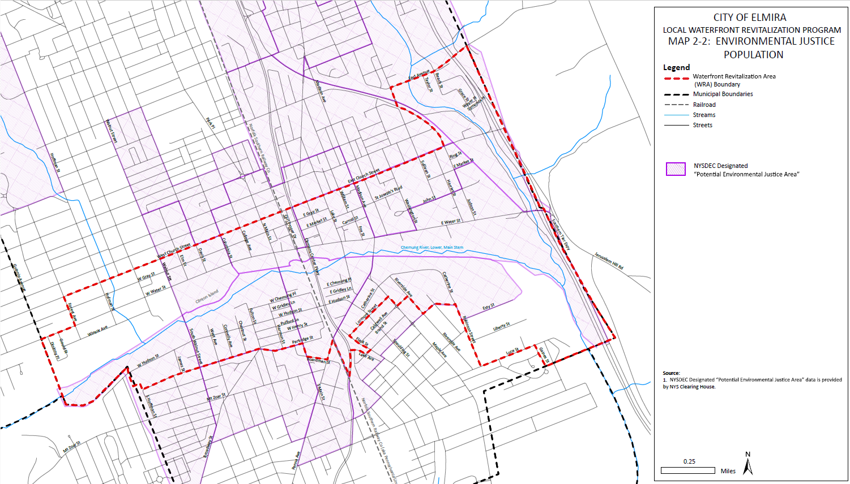
Map 2-2: Environmental Justice Populations

The majority of disadvantaged communities in Chemung County are located within the City of Elmira and Horseheads. Disadvantaged communities overlap heavily with Elmira’s waterfront, including the area from Walnut Street to the city line north of the river, though existing waterfront access is inadequate. These communities also contain a higher percentage of the city’s minority populations. It is commonly understood that minority populations are disproportionately impacted by the issues faced in environmental justice communities, including proximity to pollution and hazardous wastes, climate factors, health disparities, and critical service gaps. Local examples that disproportionately impact these communities include (the proliferation of remediation sites is detailed in 2.3 J. Remediation Sites lead piping affecting drinking water is detailed in Section 2.1 E, Utilities and impacts of flooding are detailed in Section 2.5 Flooding and Erosion)

Public Transportation
Public transportation is centered around the Chemung County Transportation Center, located at the intersection of West Church Street and Railroad Avenue. Local, regional, and intercity bus services utilize the center.

C TRAN operates fixed routes and demand response services in the WRA Boundary. The agency operates nine local routes from the Chemung County Transportation Center, providing access within the City of Elmira and surrounding towns and villages including the Town of Elmira, Elmira Heights, West Elmira, Horseheads, Big Flats, and Southport. In addition, C TRAN has commuter bus routes running from Chemung County to Ithaca, Corning, and Owego via Sayre, PA. Fares range from $.25 to $6, depending on the destination and special rates. Service generally runs every hour for most routes, though some routes deviate from this schedule. All CTRAN routes, with the exception of Route 7-Shopper Shuttle, stop at the Chemung County Transportation Center at the intersection of W Church Street and Railroad Ave, in the WRA. Additionally, Route 5-Crosstown contains several stops along Church Street and Water Street in the WRA, providing east-west linkages for the WRA’s public transportation network.

Intercity bus transportation is provided by a variety of carriers and includes destinations such as Binghamton, Rochester, Buffalo, Albany, New York City, Harrisburg, PA, Scranton, PA, and Philadelphia, PA. Connections are also available to the Elmira Corning Regional Airport.

Threats to Transportation Systems
As identified in the Chemung County Hazard Mitigation Plan (2019), the greatest threats to Chemung County are flooding, winter storms, and thunderstorms. These hazards present threats to both populations and infrastructure, including transportation systems throughout the WRA. The greatest of these threats come from flooding, which has the potential to inflict significant damage to roadways from scouring. Additionally, past floods have caused significant structural damage to bridges across both the Chemung River and Newtown Creek. In some cases, these bridges needed full reconstruction and replacement. Beyond direct impact to infrastructure, the Hazard Mitigation Plan highlights that damage to transportation systems may further economic losses experienced during flooding, exacerbated by the expensive and lengthy repairs that would be required to return this infrastructure to service.

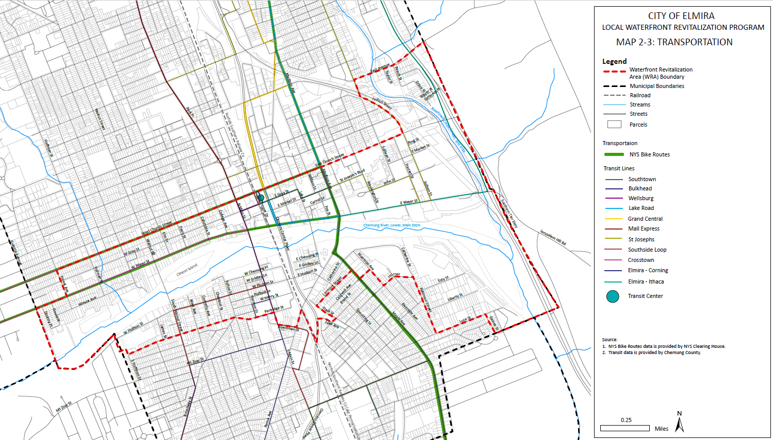
Map 2-3: Transportation

All transportation systems in the WRA are susceptible to flooding, but infrastructure outside of the flood protective structure such as bridge and transportation features beyond the levees may experience heightened vulnerabilities.

Bicycle and Pedestrian Facilities
According to the City of Elmira sidewalk survey, completed in 2023, sidewalks and ADA curb ramps are present on most roadways within the WRA. Sidewalk conditions were, on average, worse within the WRA when compared to the City of Elmira as a whole. Opportunities are present to improve the condition of sidewalks, particularly on roadways with key access to public parks and the waterfront. This survey does not rate the conditions of trails and sidewalks not located alongside roadways, such as those within parks and plazas and multi-use trails.
There are three multi-use trails in the WRA: the Lackawanna Rail Trail, the Riverfront Levee Trail, and the Lake Street Bridge. These facilities are further detailed in Section 2.6-C: Tourism Resources.

Freight

On-Road Freight
I-86 is the most significant freight corridor within the region with the majority of freight being carried by trucks and minimal freight carried by rail. A significant number of tractor-trailers enter Elmira using Clemens Center Parkway the dedicated truck route for NY-14 which crosses the Chemung River in a north-south alignment, bisecting the WRA. As the city seeks to expand pedestrian accessibility and safety along this route, traffic volume will need to remain a key consideration with any new additions. Freight traffic travel on urban roads in the City of Elmira is also a consideration as it causes considerable wear to the city streets and curbs.

Rail and Air Freight
Norfolk Southern (NS) Railroad owns all rail lines in the WRA. These lines provide service from Buffalo to the Port of New York and New Jersey. The vast majority of rail traffic in this region is not destined for nor does it originate from Chemung County, but its rail infrastructure nonetheless provides an important connection within New York’s rail network. This is likely due to local industries not be utilizing the rail network to its fullest potential, relying more heavily on truck freight. The Elmira Corning Regional Airport provides supplementary air freight, with most of the freight handled via Syracuse Hancock International Airport, where it is then transported to its final destination.

Utilities

Water Supply and Disposal
The WRA is served by public water which is provided by the Elmira Water Board. The Elmira Water Board has treatment and distribution facilities throughout Chemung County and is responsible for all connecting waterlines, meters, meter connections, and remote-read devices. According to the Elmira Water Board 2023 Annual Report, most water mains within the northern portion of the WRA date to 1915 or earlier, with some recent replacements along East Water Street. South of the Chemung River, water main ages vary. Most water mains were installed in 1915 or earlier along the waterfront and between Broadway Street and Pennsylvania Avenue, though mains have been installed/upgraded throughout the decades. For the remainder of the WRA south of the Chemung River, the age of water mains ranges from 1926 to 2016. Water mains installed before 1986 may contain lead, though most of the Elmira Water Board’s mains are made of cast iron and are reaching the end of their useful life. The Elmira Water Board has identified the need to replace these mains, but funding for such projects is limited.
The WRA is part of the Chemung County Elmira Sewer District. The district utilizes a treatment facility located on Milton Street in the town of Southport, NY. The collection network of this sewer system spans nearly 4,300 acres reaching over 45,000 people.
Additional information is detailed in Section 2.3-D: Water Supply and Disposal.

Gas and Electric
Gas and electric utilities are available throughout the WRA, with services provided by New York State Electric & Gas (NYSEG).

2.2 Summary of Existing Plans, Projects, & Initiatives that Affect the Waterfront

A. Municipal Comprehensive Plan

City of Elmira Comprehensive Plan (2016)
In 2016, the City of Elmira updated their Comprehensive Plan for the first time since 1998. The plan worked to build off the City’s 1998 Master Plan to curb population decline and job loss, address the aging housing stock and infrastructure, build a new sense of identity, and reconnect the City and Downtown with the Chemung River. The plan also identified areas where the city can improve sustainability, walkability, and climate change mitigation practices.

B. All-Hazard Mitigation Plan

Chemung County Hazard Mitigation Action Plan (2019)
In 2019, Chemung County and participating local jurisdictions created a hazard mitigation plan to address a variety of potential hazards, including winter storms, thunderstorms, flooding, tornadoes, and landslides. The plan highlights risks and existing actions communities have taken to mitigate hazards and prioritizes actions communities can take to further minimize the impacts of hazards.

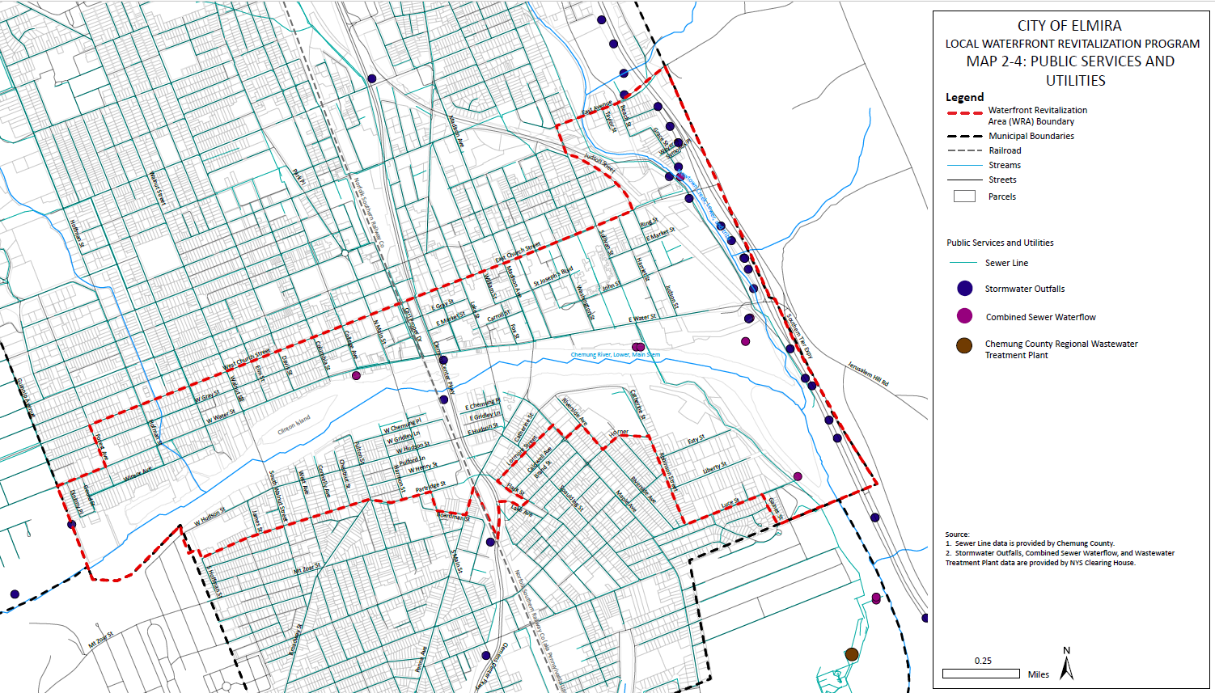
Map 2-4: Public Services and Infrastructure

C. Watershed Management Plans

Chemung County Water Quality Strategy Plan Update (2024)
The Chemung County Water Quality Strategy Plan was created to address water quality issues in Chemung County’s waterways. The plan was most recently updated in 2024 and evaluates and categorizes the County’s water quality concerns, coordinates between agencies in the County and local communities, and proposes solutions to alleviate water quality impairments.

Planning In Water’s Way, a Land Use Guide for the I-86 Innovation Corridor (2019)
The I-86 Innovation Corridor Plan was created in response to significant flooding along the Interstate 86 (I-86) corridor, including the 1972 flood affecting the entire region. The plan includes many of the communities in Chemung and Steuben Counties. The plan identifies land uses that will work to advance the economic development of the corridor while reducing the impacts of flooding along the corridor’s major rivers and streams.

D. Downtown Revitalization Plans

Chemung County Economic Development Strategic Plan (2024 Update)
The Economic Development Strategic Plan identifies strategies to strengthen a variety of economic factors in the County, including downtown revitalization and investment in underutilized, vacant and underdeveloped sites. The plan encourages historic downtowns and village centers across the County to create dense, pedestrian oriented development, enhance the aesthetic qualities of historic downtowns, and promote business and residential development inside communities’ downtown areas.

Southside Rising Revitalization Strategy (2016)
The Southside Rising Revitalization Strategy is a Brownfield Opportunity Area Study focusing on the section of Downtown south of the Chemung River, from South Main Street to Robinson Street. The plan highlights strategies to reuse vacant and underutilized former industrial parcels, as well as neighborhood specific development plans, highlighting strategies for transportation systems, open space, development patterns, and revitalization strategies for each of the four subsections in the neighborhood.

Downtown Revitalization Initiative Strategic Investment Plan (2017)
In 2017, the City of Elmira was awarded the Downtown Revitalization Initiative (DRI) for the Southern Tier Region, resulting in the DRI Strategic Investment Plan. The plan focuses on the core of downtown and recommends a variety of projects to support small business, activate key buildings downtown, build new mixed-use development, and develop connections between downtown and surrounding neighborhoods.

E. Community Resiliency Plans

Chemung County Age-Friendly Community Action Plan (2015)
Due to Chemung County’s increasingly aging population, the Chemung County Age-Friendly Community Action Plan identifies strategies to make aging in place possible for the residents in the County. The plan identifies opportunities to develop or improve amenities such as open spaces, healthcare options, and community events to make the county more livable for aging residents as well as the overall community.

F. Open Space Plan
There are no Open Space plans affecting the LWRP area.

G. Recreation Plans

Chemung River Trail: River Trail Assessment and Master Plan (2008)
The Chemung River Trail plan identifies opportunities to improve a trail connecting the north and south sides of the Chemung River within Chemung County. The plan identifies routes for a future trail using the existing resources and open space around the Chemung River, including existing waterfront parks, levees, and former railroad rights-of-way.

Elmira-Chemung Bicycle Pedestrian Trail Plan (2015)
The City of Elmira and Chemung County partnered in 2015 to create a master plan for bicycle and pedestrian facilities. The plan describes detailed opportunities and challenges for bike/pedestrian friendly infrastructure, trails, and education throughout the County and City of Elmira.

H. Other Plans

Chemung County Final Local Solid Waste Management Plan (2015)
The Local Solid Waste Management Plan serves as a framework for the coordination of solid waste management countywide, identify opportunities for climate friendly solid waste management strategies in the County, and satisfy NYSDEC requirements for such a plan from 2016-2025. The plan also measures the impacts of specific uses of the system and impacts of waste collection on the environment.

Downtown Elmira Market Rate Housing Demand Study (2020 Update)
The Downtown Market Rate Housing Demand Study is an update to a 2016 plan undertaken to study the demand for market rate housing in Downtown Elmira. The 2020 update includes changes in land-use patterns, major employers, and large development happening in and around Downtown Elmira since 2016. The plan identifies the major drivers of housing development in Downtown Elmira, including the needs of existing housing and the demand for housing typologies in the downtown area.

Housing Market Study: Chemung County & City of Elmira (2023)
The Housing Market Study assesses the types of demand for housing in both the City of Elmira and Chemung County. The Study indicates that there is a demand for different types of housing than what is predominantly on the market today. This includes multifamily residences, mixed-use development, and buildings with smaller units than may be currently present.

Regional Comprehensive Economic Development Strategy (CEDS) (2024 Update)
Prepared by Southern Tier Central (STC), the CED 2024 Update is an update to the 2020 CEDS and includes recommendations for the region and insights about forthcoming trends for STC’s partners. The CEDS covers the entire Southern Tier and will address the relationships and collective actions necessary for economic vitality in our region, given the present and expected future conditions.

2.3 Existing Land and Water Uses

A. Land Use
The WRA is located in a developed urban area within the City of Elmira, with multiple land uses located in close proximity to each other. The nine different WRA land uses include agriculture, commercial (including mixed-use), industrial, residential, recreation/entertainment, public services, vacant land, community services, and wild, forested, or conservation land, including public parks.
Table 2-5: Land Use Distribution
Land Use | Percent of WRA
Vacant Land | 24.8%
Residential | 21.1%
Commercial | 18.4%
Other | 14.0%
Community services | 5.7%
Wild, forested, conservation lands and public parks | 4.7%
Public services | 3.6%
Industrial | 3.2%
Agriculture | 2.3%
Recreation and entertainment | 2.2%

The largest land use by area in the WRA is vacant land, primarily concentrated along the Chemung River and Newtown Creek. Much of the vacant land in the WRA is occupied by flood control structures, including levees, dams, and flood benches, though other vacant land exists. The second largest land use is residential, including one, two, and three family buildings, followed by commercial concentrated along the Main, Church, and Water Street corridors, including Downtown Elmira. Community services (mostly medical uses including St. Joseph’s Hospital, the Elmira Psychiatric Center, and the Chemung County Health Department and their supporting uses), occupy a large area of the eastern portion of the WRA north of the Chemung River.

B. Zoning
Figure 2-10: Zoning Table
The City of Elmira updated its zoning code in 2020 for the downtown area, creating the City Center Form Based Code. Including the existing code outside of the central business district, there are 14 zoning classifications within the WRA, which can be generalized into five basic zoning categories – commercial/mixed use, conservation, industrial, institutional, and residential uses, defined below.

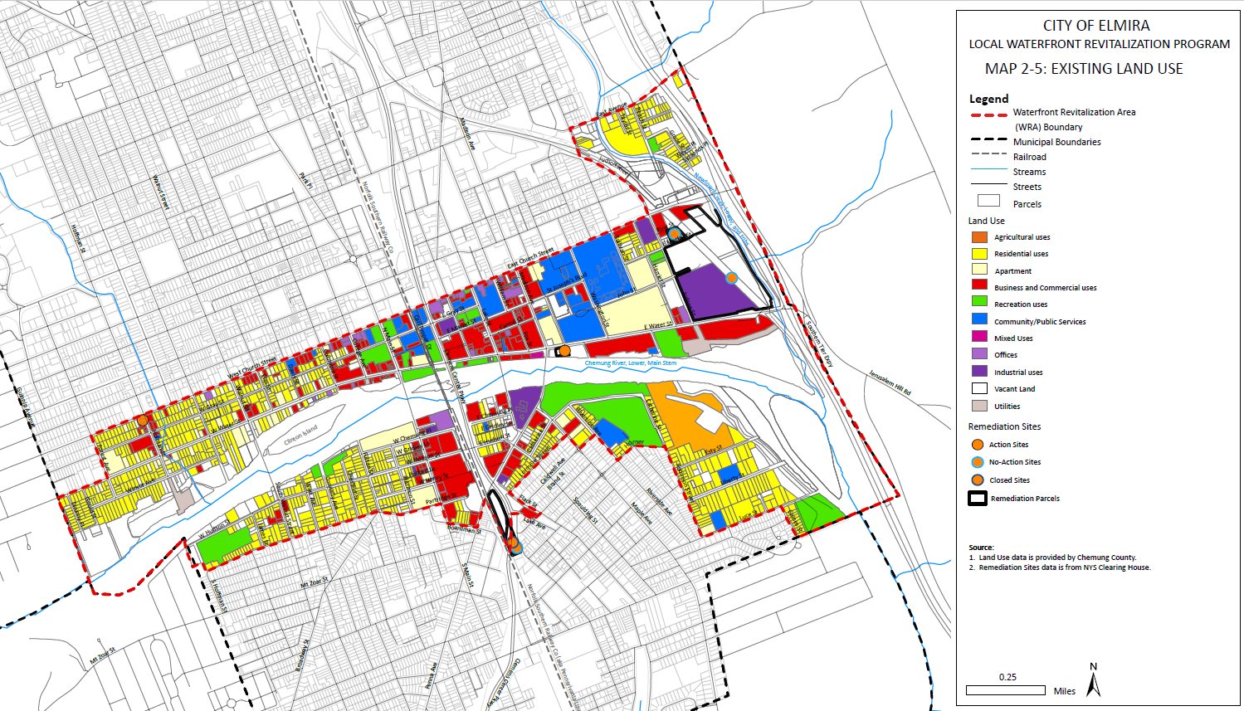
Map 2-5: Existing Land Use

Residential

RA: Residential 1 Family
North of the Chemung River, the Residential 1 Family district generally corresponds to areas west of Hoffman Street and areas northeast of Newtown Creek in the WRA. South of the Chemung River, the district general corresponds to areas south of Hudson Street and East of Fulton Street and east of Riverside Avenue in the WRA. According to the City of Elmira Zoning Ordinance, this district is intended to create, preserve and enhance areas of the city composed primarily of single-family residences built at low or medium densities on quiet streets but developed on smaller lots. Allowed uses are defined by the City of Elmira Zoning Ordinance Table 260 and include, but are not limited to detached single-family residences, manufactured homes, home occupations, garages, storage buildings (>200 sf) day care facilities, public parks, schools, and churches.

RB: 1-2 Family
North of the Chemung River, the Residential 1-2 Family district is generally found between Hoffman Street and Columbia Street. South of the Chemung River, the district is generally found in the areas; north of W Hudson Street, east of Fulton Street, and west of main street; along Lormore Street west of and including 307 Lormore Street, along Catherine Street west of and including 305 Cathine Street, and between the NS rail line and Pennsylvania Avenue. According to the City of Elmira Zoning Ordinance, the district is intended to create, preserve and enhance areas of the city that are primarily residential in character, but are composed primarily of one- and two-family dwellings on lots large enough to provide parking and open space. Allowed uses are defined by the City of Elmira Zoning Ordinance Table 260 and include, but are not limited to, uses of the RA district as well as attached single family houses, 2-family homes, and mobile home parks.

RC: Residential 1 to 4 Family
North of the Chemung River, the Residential 1-4 Family district is generally found along E market Street and Harriet Street, and between Judson Street and Newtown Creek North of E 2nd Street. South of the Chemung River, the district is generally found along Lormore Street east of 307 Lormore Street, along Catherine Street east of 305 Cathine Street. According to the City of Elmira Zoning Ordinance, this district is intended to create, preserve and enhance areas of the City that are primarily residential in character but built at a more medium density than any of the previous residential districts. Allowed uses are defined by the City of Elmira Zoning Ordinance Table 260 and include, but are not limited to, uses of the RA and RB districts as well as 3- family homes, 4-family homes, boarding houses, and nursing homes.

RD: Residential Multi-Family
The Residential Multi-Family district is found in location throughout the WRA, generally corresponding to existing multi-family developments. This includes Riverview Apartments north of W Chemung Place, Edward Flannery Apartments on S Main Street, and the areas surrounding Dewittsburg and Eastgate Homes confined by E Water Street, Judson Street, E Market Street, Sullivan Street, John Street, and Washington Court. According to the City of Elmira Zoning Ordinance, this district is intended to create, preserve and enhance areas of the City that are primarily residential in character but built to higher densities than any of the previous districts. Allowed uses are defined by the City of Elmira Zoning Ordinance Table 260 and include, but are not limited to, uses of the RA, RB, and RC district, excluding home occupations, as well as multi-family buildings.

Commercial/Mixed Use

BA: Neighborhood Commercial
South of the Chemung River, the Neighborhood Commercial district is found in multiple areas, including the intersection of Partridge Street and Fulton Street and the intersection of S Walnut Street and W Hudson Street. North of the Chemung River, the Neighborhood Commercial district is found along Hoffman Street between W Water Street and W Church Street. According to the City of Elmira Zoning Ordinance, the intent of this district is to create, preserve, and enhance business area that serve surrounding residential neighborhood day-to-day needs. Allowed uses are defined by the City of Elmira Zoning Ordinance Table 260 and include, but are not limited to, attached and detached single family homes, manufactured homes, and a variety of neighborhood serving commercial businesses. Additionally, 2-family homes, 3-family homes, 4-family homes, multi-family buildings, and condominiums, among other uses, are allowed by special permit.

BB: Central Commercial
The Central Commercial district is found along the Main Street Corridor in the WRA. Specifically, it is found between Columbia Street and Madison Avenue north of the Chemung River and between the parcels fronting the west side of South Main Street to the NS Rail line. According to the City of Elmira Zoning Ordinance, the district is intended to create, preserve, and enhance the Central Business District as a regional commercial center Allowed uses are defined by the City of Elmira Zoning Ordinance Table 260 and include, but are not limited to, uses allowed in the BA district, excluding detached single-family homes and manufactured homes, select larger commercial facilities that serve an area beyond the immediate neighborhood, Additionally, 2-Family homes, 3-famiy homes, 4-family homes and laundromats are permitted uses (compared to special permit in the BA district.

BC: Specialized Commercial
The Specialized Commercial district corresponds to properties fronting Maple Avenue south of Catherine Street in the WRA. According to the City of Elmira Zoning Ordinance, the district is intent to allow for a variety of limited commercial uses in historic properties along Maple Avenue. Allowed uses are defined by the City of Elmira Zoning Ordinance Table 260 and include, but are not limited to, including attached and detached single family homes, 2- family homes, 3-family homes, 4-family homes, manufactured homes, and select commercial facilities. Additionally, multi-family homes, among other uses, are allowed by special permit.

BD: Historic Commercial.
The Historic Commercial District, located along W Church Street between College Avenue and Hoffman Street. According to the City of Elmira Zoning Ordinance, the district is intended to allow for select commercial uses in the district while preserving the existing residential character of W Church Street. Allowed uses are defined by the City of Elmira Zoning Ordinance Table 260 and include, but are not limited to, attached and detached single family homes, 2-family homes, 3-family homes, and 4-family homes, and select low impact commercial uses. Additionally, multi-family homes and condominiums, among other uses, are allowed by special permit.

BE: General Commercial
The General Commercial district is found along Pennsylvania Avene west of the NS Rail Line and along Madison Avenue, south of the Chemung River. According to the City of Elmira Zoning Ordinance, the district is intended to create, preserve and enhance business areas devoted to general commercial services and wholesaling activities. Allowed uses are defined by the City of Elmira Zoning Ordinance Table 260 and include, but are not limited to, select commercial facilities, and select manufacturing facilities by special permit. Notably, residential uses are not permitted.

BG: Gateway Commercial
The Gateway Commercial district is found along E Water Street between Madison Avenue and Sullivan Street in the WRA. According to the City of Elmira Zoning Ordinance, the district is intended to allow for commercial development while preserving the transportation capacity of Church Street and Water Street. Allowed uses are defined by the City of Elmira Zoning Ordinance Table 260 and include, but are not limited to, attached and detached single family homes, 2-family homes, 3-family homes, and 4-family homes, multi-family homes, condominiums, hotels and motels, and a variety of commercial facilities.

Conservation

CONS: Conservation
The Conservation district corresponds to all public parks within the WRA and areas along the Chemung River between the flood protective structures on the north and south sides of the Chemung River. According to the City of Elmira Zoning Ordinance, the district is intended to create, preserve and enhance areas of the city for the protection of flood plains, natural water basins and steep lands abutting limited access highways where uncontrolled development would be adverse to community values and adverse to the public health, safety and general welfare of the city.

Institutional

HA: Hospital
The Hospital District is limited to the area between Madison Avenue, E Church Street, Sullivan Street, John Street, Washington Street and E Water Street in the WRA, generally corresponding to St. Joseph’s Hospital, the Elmira Psychiatric Facility, and the Chemung County Health Department. According to the City of Elmira Zoning Ordinance, the district is intended to create, preserve, and enhance integrated and unified hospital areas devoted to medical, surgical and other therapeutic establishments. Allowed uses are defined by the City of Elmira Zoning Ordinance Table 260 and include, but are not limited to, attached and detached single family homes, 2-family homes, 3-family homes, and 4-family homes, select commercial uses, and hospitals. Additionally, multi-family homes and condominiums, among other uses, are allowed by special permit.

Industrial

IA: Light Industrial
The Light Industrial district is found throughout the WRA, typically corresponding to historically industrial areas. This includes W Church Street between Sullivan Street and the former Lackawanna Railroad, 150 Judson Street, 1021 E Water Street, 79 Pennsylvania Avenue, and properties along Clemens Center Parkway south of Pennsylvania Avenue. According to the City of Elmira Zoning Ordinance, this district is intended to create, preserve and enhance industrial areas devoted primarily to manufacturing establishments, research establishments and other non-residential and non-business types of activities which have limited external impact on surrounding areas. Allowed uses are defined by the City of Elmira Zoning Ordinance Table 260 and include, but are not limited to, allowed uses are defined by the City of Elmira Zoning Ordinance Table 260 and include, but are not limited to, select commercial and industrial facilities (excluding recycling facilities). Notably, residential uses are not permitted.

IB: General Industrial
The General Industrial district is limited to 900 E Water Street in the WRA. According to the City of Elmira Zoning Ordinance, this district is intended to create, preserve and enhance industrial areas devoted to manufacturing and other non-business and non-residential uses which are potentially incompatible with most other activities. Allowed uses are defined by the City of Elmira Zoning Ordinance Table 260 and include, but are not limited to, select commercial and industrial facilities. Notably, residential uses are not permitted.
By area, the largest zoning district in the WRA is Conservation, which includes parks and recreational areas and natural areas such as the Chemung River and Newtown Creek. The Conservation zone is intended to “create, preserve, and enhance areas of the city for the protection of floodplains, natural water basins, and steep lands where uncontrolled development would be adverse to community values.” While this zoning district would support water-dependent and water-enhanced uses, it may also limit the potential for other uses that do not have a conservation focus. Residential districts are found throughout the WRA, corresponding to residential areas outside of the Central Business District. They include single family, duplexes, triplex, fourplexes, and multifamily developments. Within the Central Business District, roughly defined as the areas between Columbia Street and Madison Avenue North of the Chemung River within the WRA and between properties fronting the west side of S Main Street and the NS Rail Line south of the Chemung river, and primary corridors, mixed use and commercial districts are prominent. These Commercial districts are concentrated in the downtown area north and south of the Chemung River, on the major corridors of Church Street, Pennsylvania Avenue, and Maple Avenue, and in small neighborhood commercial centers. Institutional zoning, solely consisting of hospital uses in the WRA, are in the immediate vicinity of St. Joseph’s Hospital and the Elmira Psychiatric Center. Industrial zones are primarily concentrated in active industrial areas and are further detailed in Section 2.3-C: Active Industrial Sites.
Table 2-6: Zoning Distribution
Zoning District | Percent of WRA | Zoning District | Percent of WRA
Conservation | 23.7% | Campus Tech | 4.0%
Residential 1-Family | 20.9% | Neighborhood Mixed Use | 3.5%
Urban Mixed Use | 10.2% | Multifamily | 3.3%
Residential 1-2 Family | 7.5% | Light Industrial | 2.8%
Central Business District | 7.0% | Gateway Commercial | 1.1%
Hospital | 5.8% | Neighborhood Commercial | 0.9%
Residential Edge | 4.5% | Specialized Commercial | 0.7%

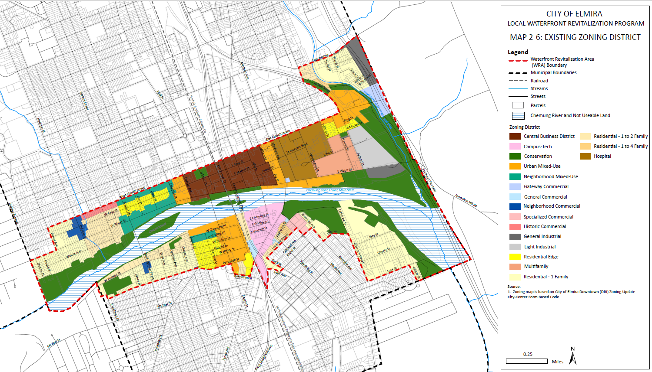
Map 2-6: Existing Zoning

C. Active Industrial Sites
Industrial land use within the WRA Boundary is relatively low. The largest and most notable industrial sites are Kennedy Valve on East Water Street and Howell Packaging on Pennsylvania Avenue. Kennedy Valve produces a full line of waterworks valves and hydrant related products and appurtenances. Howell Packaging engineers and produces high quality printed packages, cartons, and boxes. None of the active industrial sites in the WRA use the Chemung River for transportation or movement of goods or benefit directly from their location along the Chemung River.
Commercial sites make up a large portion of the WRA north of the river. Commercial sites include gas stations, bars, restaurants, vehicle repair shops, hotels, and health care facilities. South of the river, most commercial sites are congregated around Pennsylvania Avenue and South Main Street and include ALDI, Dollar Tree, and several eateries (see Map 2-5). Notable, throughout the WRA, commercial uses do not support or interact with the Chemung River and are largely auto-oriented outside of the Central Business District, with deep setbacks from the street and the Chemung River and large parking areas, limiting any interaction with the riverfront at these locations.

D. Surface Water Uses
Major surface waters in the WRA include the Chemung River and Newtown Creek. A number of smaller surface waters, including Foster Pond and Hoffman Brook are in the WRA, though Hoffman Brook is primarily underground in the WRA, surfacing only when it reaches the Chemung River. The largest surface water in the WRA, the Chemung River, , is not navigable by commercial ships. Waterways in the WRA are primarily used for water supply and disposal, recreation, and conservation.

Water Supply and Disposal
The majority of the raw water supply for the WRA and the City of Elmira is sourced from the Chemung River and wells located nearby, which increases the need for projects that seek to protect this important waterbody. Currently, Chase-Hibbard Dam, a low head dam located west of Main Street, impounds water, ensuring there is an adequate supply of water from which to draw for potable water purposes. Water is drawn from the Chemung River near Foster Island, where it is treated before distribution into the system. Additional supply wells are located on either side of the Chemung River and help to meet water demand within Chemung County.
In 2020, nearly 64.5% of water utilized by the Elmira Water Board came from the Chemung River. The majority of the remaining potable water sources include water contributed by wellfields, including Foster Island #40 and #41 and Hudson Street #1A, which supplied 14.3% of the water distributed by the Elmira Water Board. The Hoffman Creek Reservoir is the City’s only other surface water supply source. The reservoir is located outside of the WRA northwest of the City of Elmira. The Reservoir is rarely utilized and provided only 0.1% of Elmira’s water supply in 2020. Figure 2-10 indicates the percentage each source contributed to the water supply in 2020.

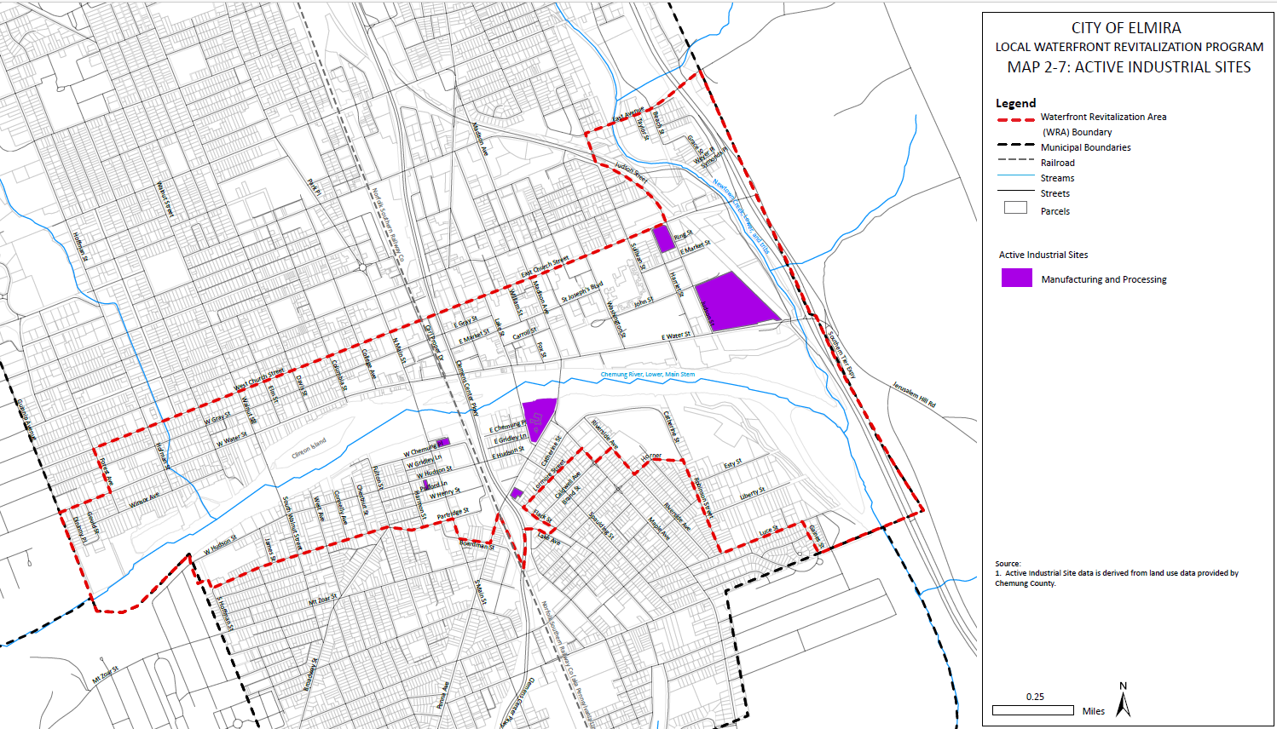
Map 2-7: Active Industrial Sites

Figure 2-11: Elmira Water Sources
Downstream from the Chase-Hibbard Dam, seven (7) permitted combined sewer overflows exist. These overflows are permitted as periodic overflows when untreated combined sanitary and storm water is released during major storm events. Further downstream, outside of the WRA, the Milton Street Wastewater Treatment Plant treats wastewater before discharging into the Chemung River. It was designed to treat 12 Million Gallons per Day (MGD) and utilizes a treatment referred to as trickling filter/solids contact. This system utilizes secondary clarifiers to clear particulate out of the water including microbes and sediments which settle to the bottom and are then removed before further sanitation is performed. The collection network of this sewer system spans nearly 4,300 acres reaching over 45,000 people.
The Milton Street Wastewater Treatment Plant is undergoing major upgrades in an effort to consolidate the Milton Street and Lake Street facilities. The Lake Street facility, which discharges treated water into Newton Creek, will be decommissioned.

Recreation
Due to its relatively shallow waters, the Chemung River is used for recreational purposes by small watercraft, including small motorboats, kayaks, and canoes. There are two boat launches within the WRA; the Grove Street Boat Launch north of the Chase-Hibbard Dam and the Dunn Field Boat Launch downstream of the dam. A portage area is available to allow for overland passage from either side of the dam. Waterbody traffic is generally light in nature due to the inability for large, motorized watercraft to utilize the river. Most recreational traffic occurs during the summer, when temperatures are warm enough to accommodate boating activities. Increased boating access, especially for small, non-motorized craft, would be desirable and likely encourage water-dependent and water-enhanced uses to locate within the WRA.
The Chemung River is used for recreational fishing as well. Fishing can occur in many areas along the Chemung River, as many of the levees are either informal accessibility points used by the public or are publicly accessible, though few formal access points exist. Though some fishers use the low-head dam to reach further into the river, this is highly discouraged due to the potential for fatal accidents. Potential solutions to discourage this activity including barriers and signage, should be explored as part of this LWRP.
While recreation is the primary use of the Chemung River, it is largely underutilized. This may be due to the difficulty of accessing the river due to the presence of flood protective structures including flood walls and levees.
Recreational resources are further detailed in Section 2.6-C: Tourism Resources.

Conservation
The Chemung River is an important natural resource. Several islands along the river, including Clinton Island and Jones Island, are unsuitable for development but provide habitat areas for birds and other wildlife that rely on the river. Visitation of these islands is discouraged due to their natural resource sensitivity. These islands may also be submerged during heavy rainfall and storms, and are often void of vegetation, though that may not have always been the case. Clinton Island is home to nesting osprey, as well as other species of birds, and many river animals use the island for habitat or refuge. These islands are recognized as important resources and should remain dedicated to natural resource preservation . This may necessitate formal protection on the local level as a recommendation of this LWRP.
Additional natural resources associated with the Chemung River are detailed in Section 2.4: Natural Resources.

E. Underutilized, Abandoned or Deteriorated Sites
Though much of the WRA is developed, there are 98 underutilized sites comprising a total of 89.2 acres. Underutilized sites are those that contain development of some kind, including buildings, parking lots, and community uses, but may have the potential for higher or more productive uses, given their location, zoning designations, and access to infrastructure and resources. These underutilized sites are primarily in the commercial and institutional areas directly north and south of the Chemung River along South Main Street, East Water Street, East Market Street, and East Church Street.
There are a variety of abandoned and deteriorated sites in the WRA, many of them residential in nature, due to the decades of decline experienced in the City of Elmira and Chemung County. The City of Elmira Department of Code Enforcement is responsible for ensuring that all properties comply with city and New York State building codes, including condemning properties that are unfit for occupation, which may result from prolonged abandonment. An overview of these properties was not undertaken as part of this LWRP. Abandoned and deteriorated commercial sites include 118-120 S Main Street and 112-116 Lake Street. There are no abandoned industrial sites within the WRA. The limited number of non-residential sites is due to the common practice of demolishing properties that have deteriorated to the point where they pose a danger to the community. This practice has resulted in vacant sites that could be redeveloped, though it has also contributed to the erosion of Elmira’s historic fabric. Historic and Cultural Resources are further detailed in Section 2.6.
While not abandoned, the former Tops Plaza at 299 S Main Street is largely vacant. The plaza, now owned by Benderson Development, has an uncertain future and its vacancy detrimentally affects the WRA. Additionally, the Elmira Water Board will be vacating its building at 261 W Water Street, located along the Chemung River. Redevelopment of these properties and other underutilized, abandoned, or deteriorated properties is a high priority for the revitalization of the WRA, presenting opportunities to reactivate the waterfront and the city’s downtown core.
A table of underutilized or deteriorated sites can be found in Appendix A.

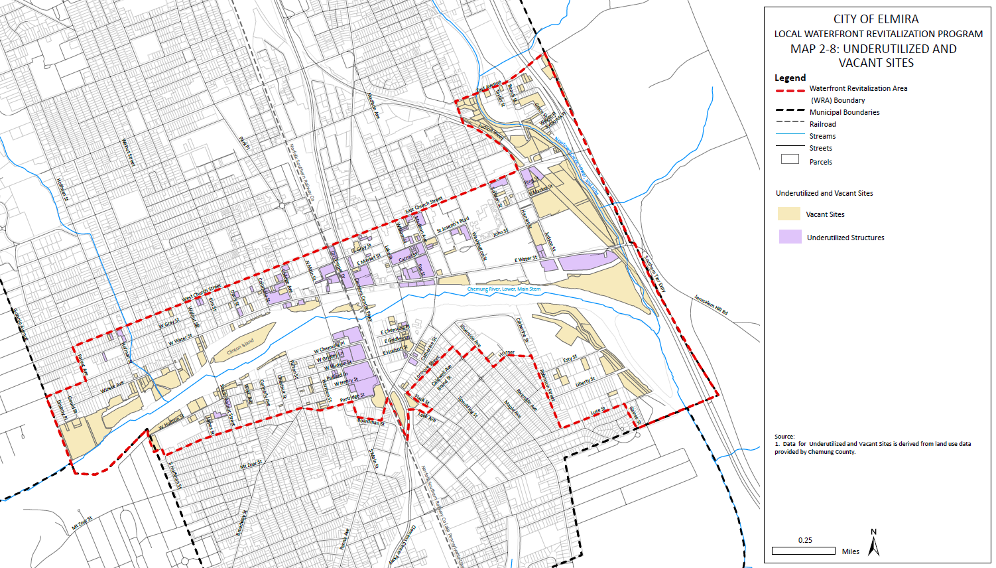
Map 2-8: Underutilized and Vacant Sites

F. Vacant Parcels
There are 236 vacant parcels within the WRA, totaling 57.23 acres. Of the 236 parcels, 153 (64.8%) are classified as residential, 72 (30.5%) as commercial, 5 (2.1%) as industrial, and 6 (2.5%) fall under other classifications such as rural, utilities, underwater, or “slum clearance.” These vacant parcels are concentrated along the Chemung River and Newtown Creek, some of which are used for flood control, conservation, or public trails. Major areas of developable vacant land are found along the Clemens Center Parkway, East Water Street, and East Church Street. Smaller residential vacant lots are scattered throughout the WRA and have varying development potential.
A table of vacant sites within the WRA can be found in Appendix B

G. Water Dependent and/or Water Enhanced Uses and Related Issues
Water dependent uses are uses that can only occur along the waterways within the WRA. This includes fishing areas, boat launches, combined sewer outfalls, and dams. Water enhanced uses can occur independent of the waterways, though their presence along waterways can enhance a site. In the WRA, this primarily includes recreation areas such as Brand Park.

Water Dependent Uses
- Fishing access and boat launches – Within the WRA, there are two formal fishing access points, both of which have boat launches for small watercraft. These include the Grove Street Boat Launch and the Dunn Park Boat Launch. Various other areas along the river, including levees and public parks, act as informal fishing access points.
- Swimming – Swimming is not encouraged or sanctioned in the Chemung River from any publicly owned foreshore lands. Additionally, according to NYSDEC waterbody classifications, Newtown Creek and the Chemung River downstream of the Chase Hibbard Dam are not suitable for swimming. Upstream of the Chase Hibbard Dam, swimming may be a more appropriate as the River is deeper, though as noted above, swimming is not currently encouraged or sanctioned in any area due to potential public safety concerns and hazards associated with water collection infrastructure operated by the Elmira Water Board. Despite this, swimming has been observed in the Chemung River, most notable around E Water Street Park.
- Combined Sewer Overflows (CSO) – Within the WRA, there are seven CSO sites, all downstream of the low-head dam. These sites represent permitted overflows during heavy storm events when runoff may overwhelm the combined sewer system and the Milton Street Wastewater Treatment Plant. Though the CSOs are utilized infrequently, their location along the waterfront is necessary to provide a “relief valve” during unusually heavy storm events when sewer infrastructure is over capacity.
- Chase-Hibbard Dam –This is a low head dam located west of Main Street. Originally, this dam was an important resource for mills located along the Chemung River, though none of the mills or their buildings remain. The dam is owned and maintained by the Elmira Water Board and is used to ensure that water levels remain high enough for water withdrawal. In 2022, the Chemung River accounted for 63% of water supplied to customers by the Elmira Water Board.

Water Enhanced Uses
- Jim Nelson Park – Jim Nelson Park is located along the south bank of the Chemung River and features a playground, pavilion, baseball field and basketball courts. The park provides viewing opportunities of the Chemung River.
- Katy Leary Park - Katy Leary Park is located along the south bank of the Chemung River and is named after Katy Leary. Originally from Elmira, she accompanied Mark Twain and his family all over the world and assisted them as a housemaid. The park is located along the riverfront at the corner of Connelly Street and River Street. It features a pavilion, tennis courts, a water sprinkler, a playground, and a summer recreation program. Katy Leary Park provides viewing opportunities of the Chemung River, including a pavilion and seating areas.
- Wisner Park – While not located directly along the Chemung River, Wisner Park is located north of the Chemung River within the WRA and is part of a connected parks system in the Downtown area. It is the home of Elmira’s summertime Farmer’s Market and the host of several other special events throughout the year. Wisner Park features memorials to the veterans of World War I, World War II, the Vietnam War, and Fallen Officers.
- Mark Twain Riverfront Park - Mark Twain Riverfront Park is located along the north bank of the Chemung River. The park features sculptures, a water fountain pond, the Citizens Cascade Fountain, and pedestrian paths and provides viewing opportunities of the Chemung River.
- Brand Park – Brand Park is the largest and most popular park within the WRA and provides viewing opportunities of the Chemung River, including a pavilion and seating areas. It includes a playground, basketball court, baseball diamonds, and tennis courts. Brand Park also features pavilions and barbecue grills.
- East Water Street Park – East Water Street Park is located along the north bank of the Chemung River and provides viewing opportunities of the river and sports fields.
- Dunn Field – Dunn Field is the city’s baseball stadium, located along the banks of the Chemung River since the 1930s. The Chemung River serves as a backdrop to baseball games and other events. Dunn Field is further detailed in Section 2.6-C: Tourism Resources.
- Frank A. Rhode Park – Frank A. Rhode Park is located along the north bank of Newtown Creek. It is one of the few publicly accessible areas along the creek.
- Chemung County History Museum – The Chemung County History Museum is enhanced by its proximity to the Chemung River, the Mark Twain Riverfront Park, and the Lake Street Bridge Trail. These features can be viewed as an outside extension to the History Museum contents and therefore provide additional education opportunities.
Some of these existing water-dependent uses may encourage activities that affect public health and the environment This includes combined sewer overflows that introduce combined stormwater and sanitary wastewater into the Chemung River during heavy storm events, negatively impacting water quality, public health and the environment, and inhibiting public recreation opportunities. Additionally, water collection activities by the Chemung Water Board necessitates the need for the Chase Hibbard Dam. This collection is essential as the river is the primary source of drinking water in the WRA, though the collection infrastructure and dam present challenges to the navigability of the river for both wildlife and humans for recreational purposes. Both the water intake structures and the dam itself also create potential dangerous current situations which have the potential to lead to injury or loss of life.

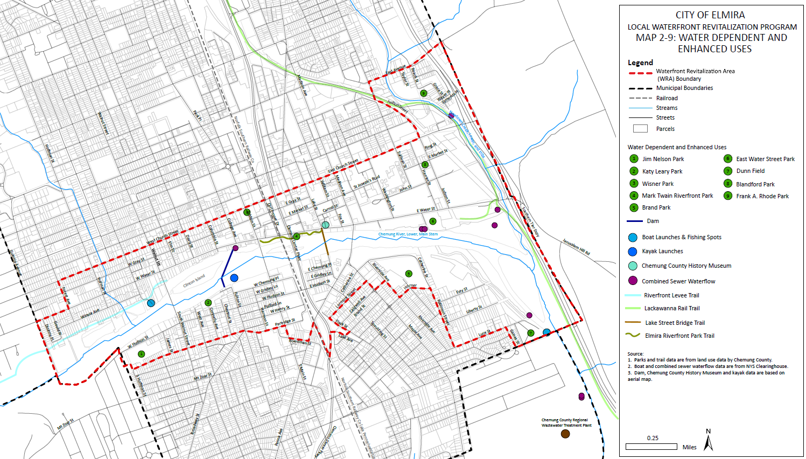
Map 2-9: Water Dependent and Enhanced Uses

H. Agricultural Uses and Agricultural Land
There is one parcel of land currently used for agriculture within the WRA near Catherine Street and Esty Street. This family-owned farm has operated on the site for over 150 years.
Chemung County has one consolidated agricultural district that encompasses approximately 40,678 acres, according to information provided by the Chemung County Agricultural & Farmland Protection Board. There are no designated agricultural districts within the City of Elmira. Existing agricultural land is largely located outside the city limits, in the Town of Elmira and neighboring towns.

I. Ownership Patterns, including underwater lands.
Most land within the WRA is privately owned, particularly in residential areas on the western side of the WRA, both north and south of the Chemung River. Directly along the river, most lands are publicly owned by the City of Elmira and the State of New York. These lands are used for flood control purposes and are generally restricted from public use. The extent of the City’s conservation district is detailed in Section 3.2, Conservation.

City-Owned Land
Most of the city-owned land consists of flood control areas along the Chemung River, nine (9) parks, City Hall, and the Centertown Parking Garage. In addition, a number of vacant lots and parking lots within the WRA are owned by the City of Elmira, which were created following previous urban renewal activities and blight removal. The City of Elmira owns most underwater areas of the Chemung River, including four semi-permanent islands within the WRA.

County-Owned Land
There are two County-owned sites in the WRA: the Chemung County Nursing Facility and the Lake Street Civic Complex. The Lake Street Civic Complex houses the County’s operations, including offices, courts, and a jail facility. The Nursing Facility is operated by the Chemung County Health Department and houses the health department and long-term nursing care.

State-Owned Lands
New York State owns two large parcels in the WRA: Jones Island and its immediate shoreline and the Elmira Psychiatric Center. Other lands owned by New York State include those used for transportation such as Interstate 86 and some flood control structures.

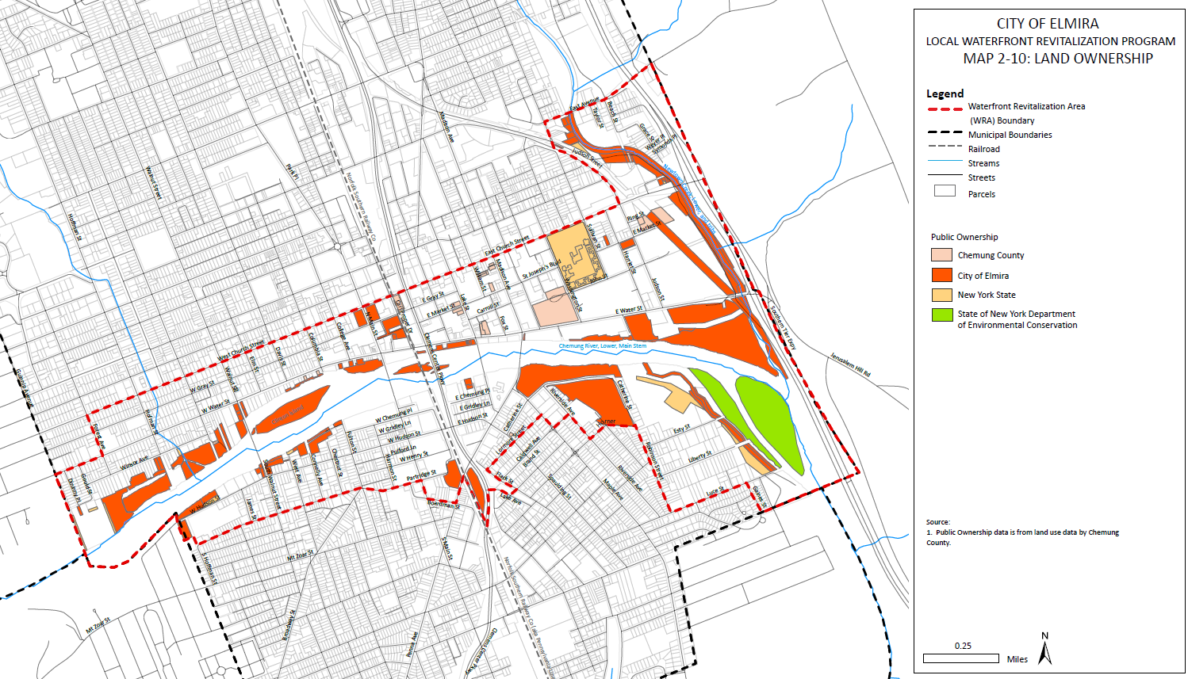
Map 2-10: Land Ownership

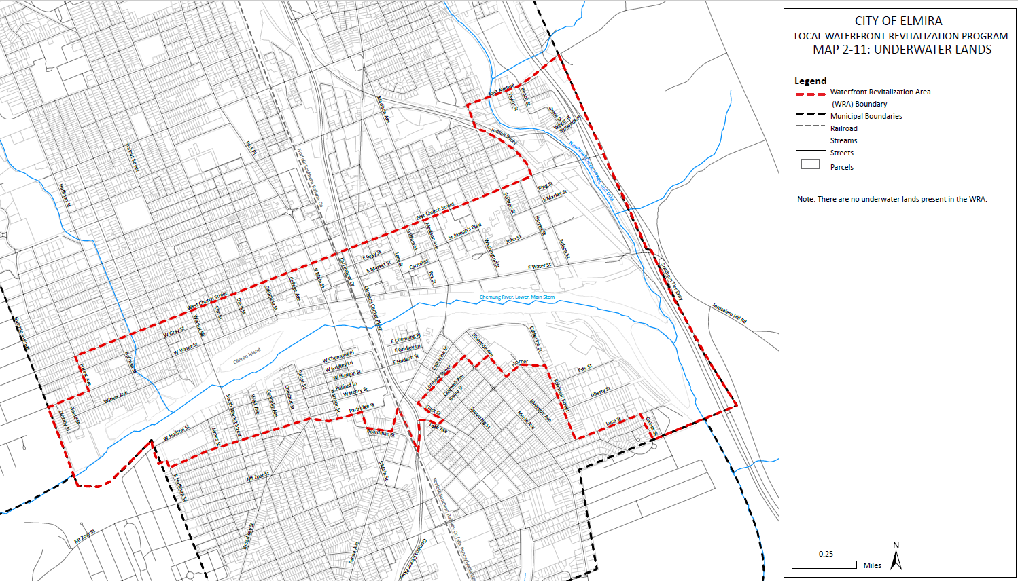
Map 2-11: Underwater Lands

Hazards to Navigation, such as abandoned barges and deteriorated pilings
The Chemung River is not commercially navigable and can be dangerous to paddlers, anglers, and swimmers without caution and vigilance. Major river hazards include deceptively calm water, fast paced currents, rapids, quickly changing water levels due to flash flooding, subsurface obstructions such as trees, cold temperatures, the city’s water intake protection columns, and the Chase-Hibbard Dam.
Throughout most of the year, the Chemung River is slow-moving and has very few rapids or steep drops. However, as the water rises (due to rainfall, snow melt, or flash flooding) the current can increase in speed and intensity and debris can be swept into the water causing additional hazards.
The Chemung River basin covers more than 2,000 acres and drains into the Cohocton, Canisteo, Cowanesque, and Tioga Rivers which all flow into the Chemung River. When heavy rainfall occurs over this area, all water flow is directed to the Chemung River and flash floods can occur. Flash flooding can occur even in clear weather if there is heavy rainfall upstream. Paddlers, anglers, and swimmers need to be aware of their surroundings and take immediate action if a sudden water level change is noted.
The City of Elmira pumps over 2 billion gallons of water each year from the Water Board-owned intake located about 1,000 yards west/upstream from the Walnut Street Bridge. This water intake structure is marked and protected by six yellow concrete columns protruding out of the water. These columns can be a hazard to paddlers and should be avoided.
The Chase-Hibbard Dam (NYS ID 061-0145) was built in the mid-1990s to replace the original Record Dam, built in the 1820s. The Chase-Hibbard Dam is six feet high and almost 1,000 feet across. The dam’s strong back current poses a serious risk to paddlers, anglers, and potential rescue personnel. The back current forms a circular current called a boil that can repeatedly drag a person and/or boat underwater and back to the surface, effectively trapping them in place. The lip of the Chase-Hibbard Dam is covered with algae and seaweed that makes it easy to slip and fall into the boil. Despite this, anglers frequently walk across and fish from the lip of the dam, illustrating the necessity to create physical barriers, signage or other measures to prevent access on the dam. The Don Hall portage was built to allow paddlers to safely navigate by foot around the dam, carrying their boats along the trail and putting them back in the river below the dam.
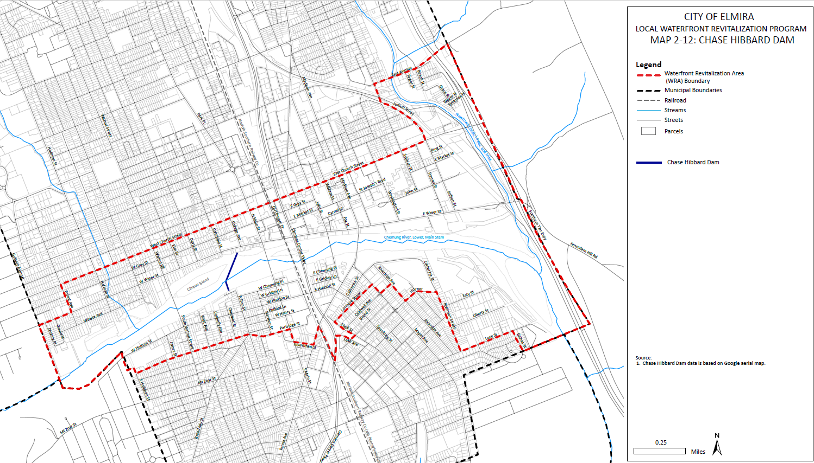
Map 12: Chase-Hibbard Dam

Local fire departments are often called to conduct river rescues for stranded boaters, hypothermic swimmers, or persons trapped in river debris. The Elmira Fire Department purchased a new river rescue boat in 2019 with the help of the Chemung River Friends, which will help cut down on rescue time and make it safer for firefighters to access the river, and the Don Hall portage was constructed.

J. Remediation Sites
According to the DEC Information Locator, the City of Elmira has twenty-seven (27) sites in the Brownfield Cleanup Program, Environmental Restoration Program, State Superfund Program, Resource Conservation and Recovery, or Voluntary Cleanup Program. Of these there are six (6) within the WRA, two (2) of which are in the Environmental Restoration Program and four (4) of which are in the State Superfund Program. The DEC Information Locator was used as the basis for the analysis below. These sites, some of which will require remediation, provide several reuse opportunities for the WRA in terms of mixed use and/or commercial infill development or new recreational investment.
The former Chemung Foundry Site sits on two parcels (originally one, spilt by the Clemens Center Parkway) off Erie Street, approximately 1500 ft south of the Chemung River. Both parcels are now vacant and registered in the Environmental Restoration Program (site code B00014). Prior uses have led to site contamination with metals and organic compounds including disposal of cooling water, quenching water, or subsurface burial of wastes. No groundwater has been impacted by the contamination according to in reports published by the DEC. A Record of Decision (ROD) was issued by the State in 2002 which required excavation and removal of lead-contaminated soil, installation of a locked gate (northern parcel), soil management plan, deed restriction prohibiting site use other than industrial or commercial and requiring annual certification to the DEC indicating that the remedy continues to be maintained in accordance with the ROD.
The former Matt Brewer Oil Site sits on two parcels off East Market Street. The northern parcel is registered in the Environmental Restoration Program (site code E808032) and the southern parcel is registered in the State Superfund Program (site code 808032). Both parcels are owned by Chemung County and are vacant. Between 1954 and the 1990s, Matt Brewer operated a bulk storage of lubricants, petroleum, and solvent on site. All above ground buildings and structures have been demolished and 33 tanks have been removed or closed in place. The site is primarily covered with low permeable concrete or asphalt and surface runoff is collected in drywell structures and infiltrates into the subsurface soils. The site holds the classification code 02 which means the disposal of hazardous waste has been confirmed and the presence of such hazardous waste, its components, or breakdown products represents a significant threat to public health or the environment. Remediation of this site will be the responsibility of the Potentially Responsible Party (PRP, defined as party or parties responsible for the contamination), with oversight from the DEC. Future redevelopment of the site may be possible depending on the level of cleanup achieved and the institutional controls in place.
Kennedy Valve Manufacturing Corporation, located just south of the former Matt Brewer Oil Site (approximately 700 ft north of the Chemung River and 250 ft west of Newtown Creek), is another site registered in the State Superfund Program (site code 808004). Brass foundry sand was disposed of in the onsite landfill in the late 1980s and early 1990s. The landfill is now capped. Samples taken from the landfill failed the Extraction Procedure (EP) toxicity test for lead. A Phase II Environmental Site Assessment (ESA) report submitted in 1992 indicated that migration of lead from the landfill could not be confirmed. However, filtered groundwater samples contained no lead and organic contamination of the groundwater has not been linked to hazardous waste disposal. The site holds the classification code N meaning there is no further action needed at this time.
Another State Superfund Program site is the New York State Electric and Gas (NYSEG) - Elmira Water St. Manufactured Gas Plant (MGP) (site code 808025) located on East Water Street near the intersection of Dewitt Street. The Elmira Water Street Manufactured Gas Plant (MGP) was constructed in 1852 by the Elmira Gas Light Company (later becoming part of NYSEG). The MGP was constructed and operated as a coal carbonization plant using coal as a feedstock until 1867. The facility continued to be used as a gas storage facility until 1869. Some time prior to 1898, the above grade portion of the gas holder was demolished. More recently, the site was the location of the former Hartman Lincoln Mercury auto dealership and repair shop which operated until 1997. Around 1998 the car dealership structures were demolished and in 1998 several underground storage tanks and hydraulic lifts were removed during a Phase II Environmental Site Assessment. During the Phase II investigation, the presence of coal tar in the area of the former gas holder was identified. Since the site is currently covered by asphalt and grass, people are not expected to have contact with site related soil contamination unless they dig below the surface. The site holds the classification code A (Active), given to sites where work is underway and not yet complete, MGP sites, or those being remediated under an EPA Cooperative Agreement.
Castle Cleaners is a State Superfund Program site located on Hoffman Street (side code 808034). The Castle Cleaners site property is a flat commercial 0.1-acre lot containing the dry-cleaning structure and a small, paved area on the west (back) side. The site has been an active dry cleaner since the mid 1950’s. The site owner reported that the building caught fire in the late 1950’s, at which time the dry-cleaning machinery fell through the floor of the building into the basement. The site was also flooded during the Chemung River flood events of 1972 after which the basement was filled, with a concrete slab poured at grade. Contact with contaminated soil or groundwater is unlikely unless people dig below the ground surface. Site-related contaminants have been detected in the downgradient public water supply wells; however, the wells are tested regularly, and people are not drinking the contaminated groundwater. The site holds the classification code 02 which means the disposal of hazardous waste has been confirmed and the presence of such hazardous waste or its components or breakdown products represents a significant threat to public health or the environment. Remediation of this site will be the responsibility of the PRP with oversight from the DEC. Future redevelopment of the site may be possible depending on the level of cleanup achieved and the institutional controls in place.
Additional detail provided in the NYSDEC’s Site Remediation Database on the five sites can be found in Appendix C.

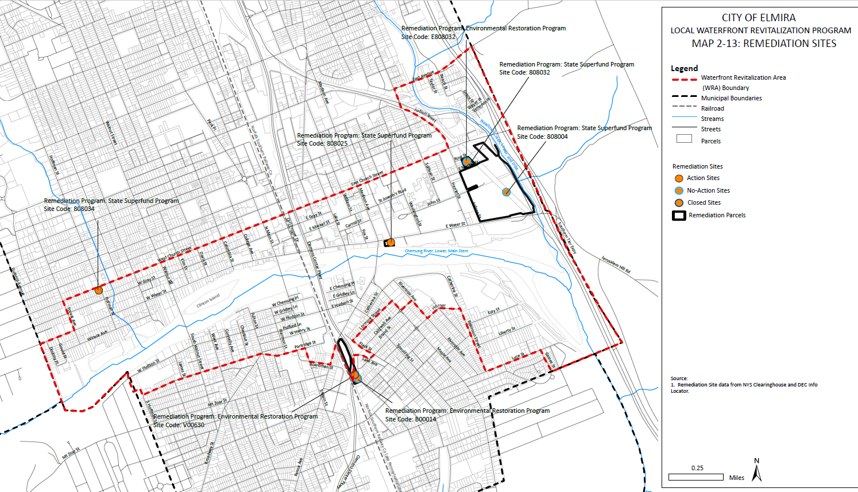
Map 2-13: Remediation Sites

K. Other Limitations to Development
The Chemung River Valley and the City of Elmira are particularly susceptible to heavy flooding, especially in Downtown Elmira. While protected by flood control levees and walls, much of the WRA has historically been prone to flooding. This potential for flooding limits both the type and cost of development within the WRA. Current economic conditions in the city make it difficult to justify the increased costs of development within the floodplain. Understanding how to overcome these limitations is a major consideration of this LWRP. Flooding is further detailed in Section 2.5: Flooding and Erosion.

L. Port or Small Harbor Development
As the Chemung River is not navigable within the City of Elmira, there are no ports or harbors within the WRA.

M. Public Services and facilities (water and sewer, vessel waste facilities, transportation, navigations channels/basins, bulkheads, docks and docking facilities)
There are no vessel waste facilities, navigation channels/basins, bulkheads, docks, or docking facilities within the WRA Boundary. The major public services within the WRA include water intake and disposal structures. As previously indicated, there are seven (7) combined sewer overflows in the WRA, six of which discharge into the Chemung River and one into Newtown Creek during heavy storm events. The Chase-Hibbard Dam ensures that there is adequate water within the Chemung River for withdrawal. Information on the Chase-Hibbard Dam and water withdrawn can be found in Section 2.3-D: Surface Water Uses.

2.4 Natural Resources
Natural Resources have been assessed within the WRA, including topography, geology, and surface and ground water resources. Within the WRA, many of these natural resources are centered around the Chemung River and its tributaries.

A. Topography and Geography
The WRA varies in elevation, with the highest point at 1,591 ft and the lowest point at 820 ft. Lower elevations, as to be expected, are located closest to the Chemung River and create the valley in which the City is located. Despite this large difference in elevation, the WRA is mostly flat with little variation in elevation along the Chemung River and west of Newtown Creek. Steep slopes exist along the edge of the WRA boundary, in the northeast corner of the WRA, and along Jerusalem Hill. The steepest slopes are located to the east and west of the WRA.

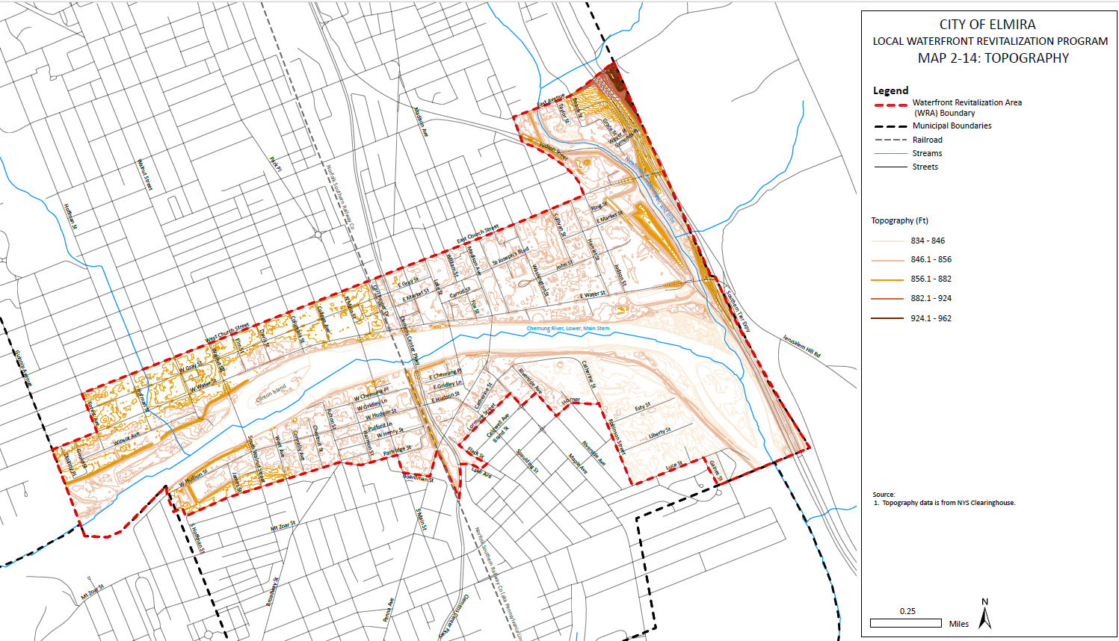
Map 2-14: Topography

Surficial Geology/ minerals/ soils of the boundary area:
The City of Elmira sits just south of the Finger Lakes Region of New York State and north of the New York State/Pennsylvania border. Because the WRA is located between different geological features and within a major floodplain, its soil has a diverse makeup. Over half of Elmira’s soil (nearly 857 acres) is classified within the Howard and Unadilla Series. Both soil series are characterized by deep, well drained soils. Deep soils are defined as locations where bedrock is at depths greater than 60 inches. Soils in the Howard Series are formed in medium-textured glacial outwash deposits, and soils in the Unadilla Series are formed in silty, lacustrine sediments or old alluvial deposits. These soils are typically found in valley terraces and outwash plains, which contribute to regional flooding patterns such as those found in the WRA. Table 2-7 lists the soil series that are located within the WRA boundary.
Table 2-7: Soils
Map Unit Symbol | Map Unit Name | Acres in AOI | Percent of AOI
Ab | Alluvial land | 85.8 | 5.6%
HoA | Howard gravelly silt loam, 0 to 3 percent slopes | 575.1 | 37.6%
Mc | Made land | 84.0 | 5.5%
MdB | Mardin channery silt loam, 2 to 8 percent slopes | 5.6 | 0.4%
MdC | Mardin channery silt loam, 8 to 15 percent slopes | 5.5 | 0.4%
Me | Middlebury silt loam | 48.1 | 3.1%
Tf | Tioga fine sandy loam | 58.8 | 3.8%
Tg | Tioga silt loam | 126.5 | 8.3%
Th | Tioga silt loam, high bottom | 59.2 | 3.9%
UnA | Unadilla silt loam, 0 to 3 percent slopes | 281.7 | 18.4%
VaC | Valois gravelly loam, 8 to 15 percent slopes | 0.1 | 0.0%
VoC | Volusia channery silt loam, 8 to 15 percent slopes | 0.1 | 0.0%
VoD | Volusia channery silt loam, 15 to 25 percent slopes | 1.6 | 0.1%
W | Water | 196.2 | 12.8%

Bedrock:
According to the New York State Museum and Science Service “Geologic Map of New York” (1970), the bedrock in the WRA boundary is classified in the West Falls Group of the Upper Devonian Period, consisting primarily of Beers Hill Shale; Grimes Siltstone; and Dunn Hill, Millport, and Moreland Shales.
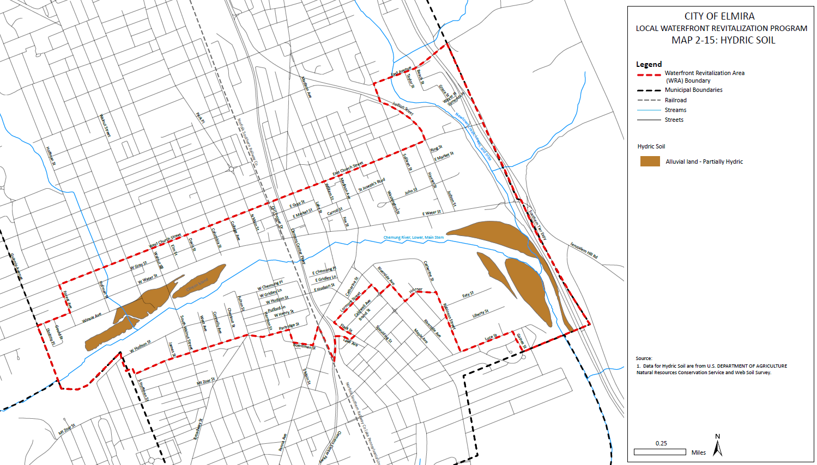
Map 2-15: Hydric Soils

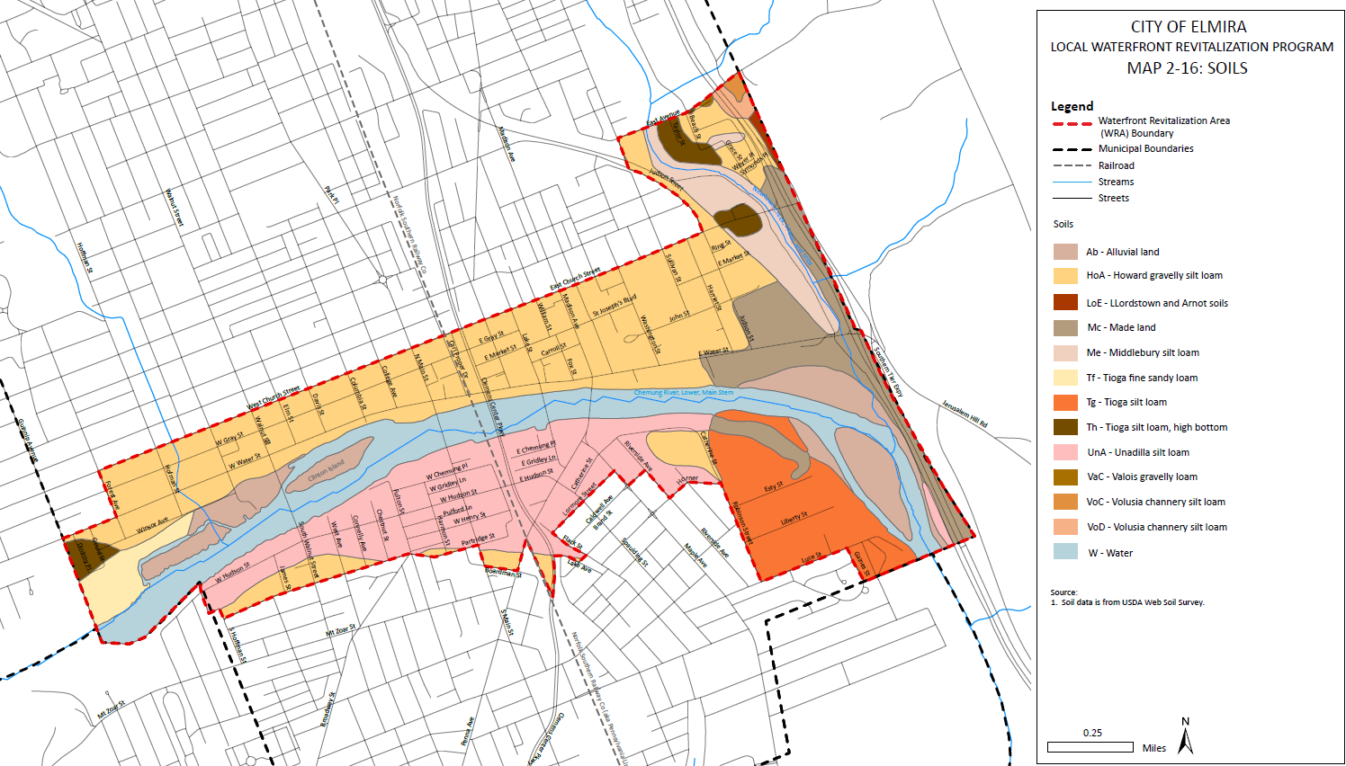
Map 2-16: Soils

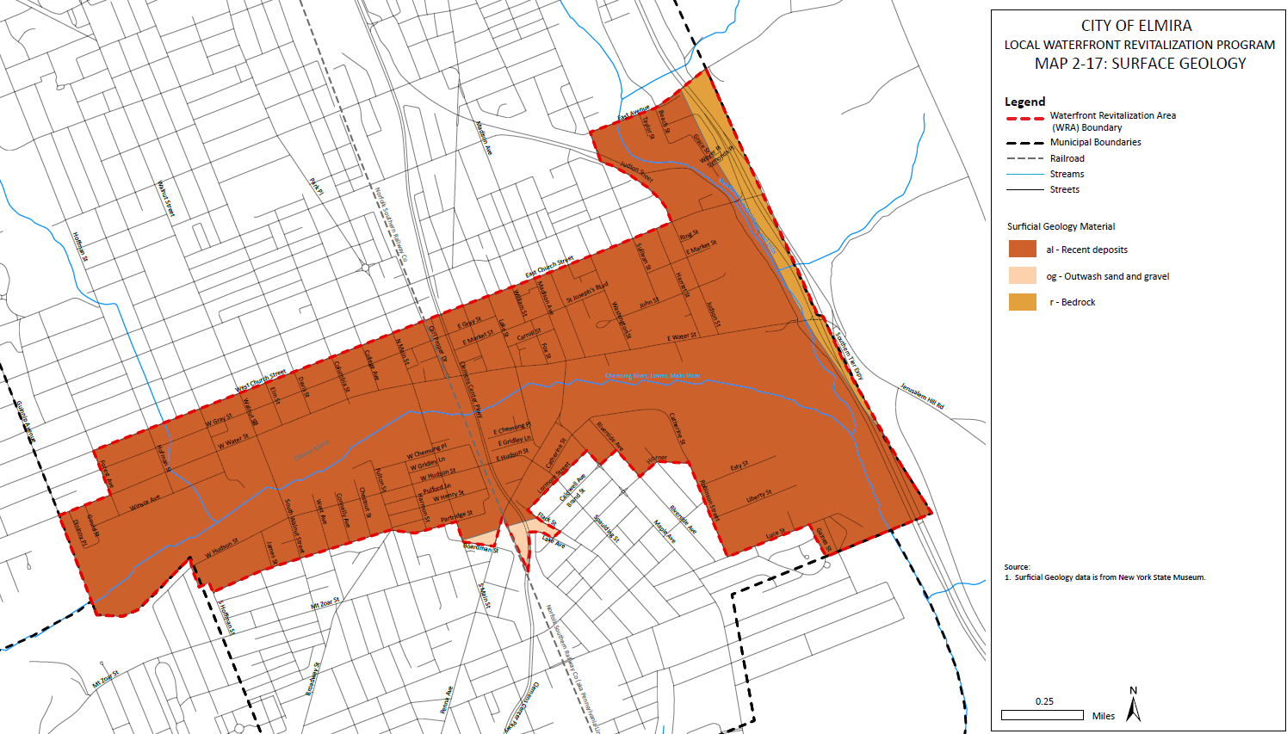
Map 2-17: Surface Geology

B. Water and Resource Quality

Ground and surface water resources for public and private water supplies:
Information on ground and surface water resources is detailed in Section 2.3-D: Water Supply and Disposal.

Point and nonpoint sources of pollution:
As water travels over the surface of land and permeates into the soil, it can carry substances including naturally occurring materials and pollutants. According to the Elmira Water Board, common source water contaminants include microbial, inorganic, pesticides and herbicides, organic, chemical, and radioactive substances.
According to the Susquehanna River Basin Watershed Profile published by the Susquehanna River Basin Commission, point sources of pollution affecting the Chemung River along the entirety of its watershed include 24 animal feeding operations, 14 mines or rock quarries, 45 stormwater outflows, and 29 wastewater treatment plant outflows, as well as 50 unspecified point sources. Nonpoint sources include runoff from mine and quarry operations, agriculture, erosion, golf courses, roads and highways, and urban areas.

Treatment of polluted water:
According to the Elmira Water Board, all untreated water drawn from the public water supply undergoes a standard treatment process which causes natural contaminants to coagulate and settle prior to filtration. Fluoride is added to treated water for the dental health of consumers and caustic soda and phosphate are added to treated water to help prevent corrosion of household plumbing.

Water quality, quantity and related infrastructure, including drinking water:
Hoffman Brook, which runs perpendicular to the Chemung River, is channelized in the City of Elmira, and conveyed underground at West 2nd Street. Upstream, in the Town of Chemung, Hoffman Brook is impounded by the Hoffman Creek Dam and an additional upstream flood control dam, forming the Elmira Reservoir. Both dams are considered “high hazard” dams due to the size of downstream populations, including the City of Elmira.
Information on drinking water resources is detailed in Section 2.3-D: Water Supply and Disposal.

Natural areas of shore-adjacent deep water including any suitable for use channels:

Watershed Information:
The Chemung River Watershed encompasses 2,600 square miles in both New York and Pennsylvania. The Chemung River flows across the western portion of New York State’s Southern Tier region before meeting the Susquehanna River south of the New York State border, eventually emptying into the Chesapeake Bay. The Chemung River Watershed represents about one-eighth of the larger Susquehanna River Basin. The Chemung River Watershed and the regular activities occurring within it, can directly affect the quality of the Chemung River, its tributaries and ecosystem. These activities may include point and non-point pollution from industry and farming practices and stormwater discharges from construction activities.

Stormwater Maintenance Descriptions and EPA Resources:

Wetlands:
Wetlands assist communities in developing natural, integrated stormwater management systems. They play a critical role in collecting stormwater runoff, providing alternative areas for excess water to collect and preventing stormwater load from reaching the Chemung River. Proper maintenance of existing wet ponds and wetlands is vital in ensuring that they can continue to collect runoff.
There are no mapped state regulated freshwater wetlands in the WRA. According to the National Wetland Inventory (NWI), 13.8 acres of freshwater emergent wetlands may exist in the WRA. The majority of these wetlands are semi-permanent islands in the Chemung River. This type of wetland is typically a transition area between permanently wet and dry areas and can support a wide variety of plant and animal life.

C. Fish & Wildlife Habitats

NYS Significant Coastal Fish and Wildlife Habitats:
There are no refuge lands or significant coastal fish and wildlife habitats in the WRA.

Critical Habitats: (found using IPaC- Information for Planning and Consultation)
The boundary for this Local Waterfront Revitalization Program overlaps with the critical habitat for the Green Floater; a threatened species of freshwater mussel. The United State Fish and Wildlife Service (USFWS) conducts ecological risk screening for species that are uncertain risks. The USFWS indicates that Green Floaters are intolerant to current flooding, erosion, and pollution. As of February 2025, the USFWS has indicated that more data is needed for this species due to lack of information on introduced populations.

Locally important fish and wildlife habitats:
Although there is not an identified Significant Coastal Fish and Wildlife Habitat Area within the WRA, the Chemung River contains the Gleen Floater, a proposed-threatened species of mollusk. For this reason, the river is considered ‘locally important’ and must be treated as a threatened species habitat. Additionally, there are no fish hatcheries present at this location.

Important Bird Areas:
The City of Elmira is home to the breeding grounds of a variety of native bird species. Below is a list of the bird species of conservation concern (BCC), whose populations are in decline, along with their breeding season within the Elmira region. As mentioned in Section 2.3 D. Surface Water Uses, non-permanent islands in the floodway of the Chemung River provide critical habitats for bird species.
According to the U.S. Fish & Wildlife Service’s Information for Planning and Consultation (IPaC) website, there are no areas of concern in the WRA.

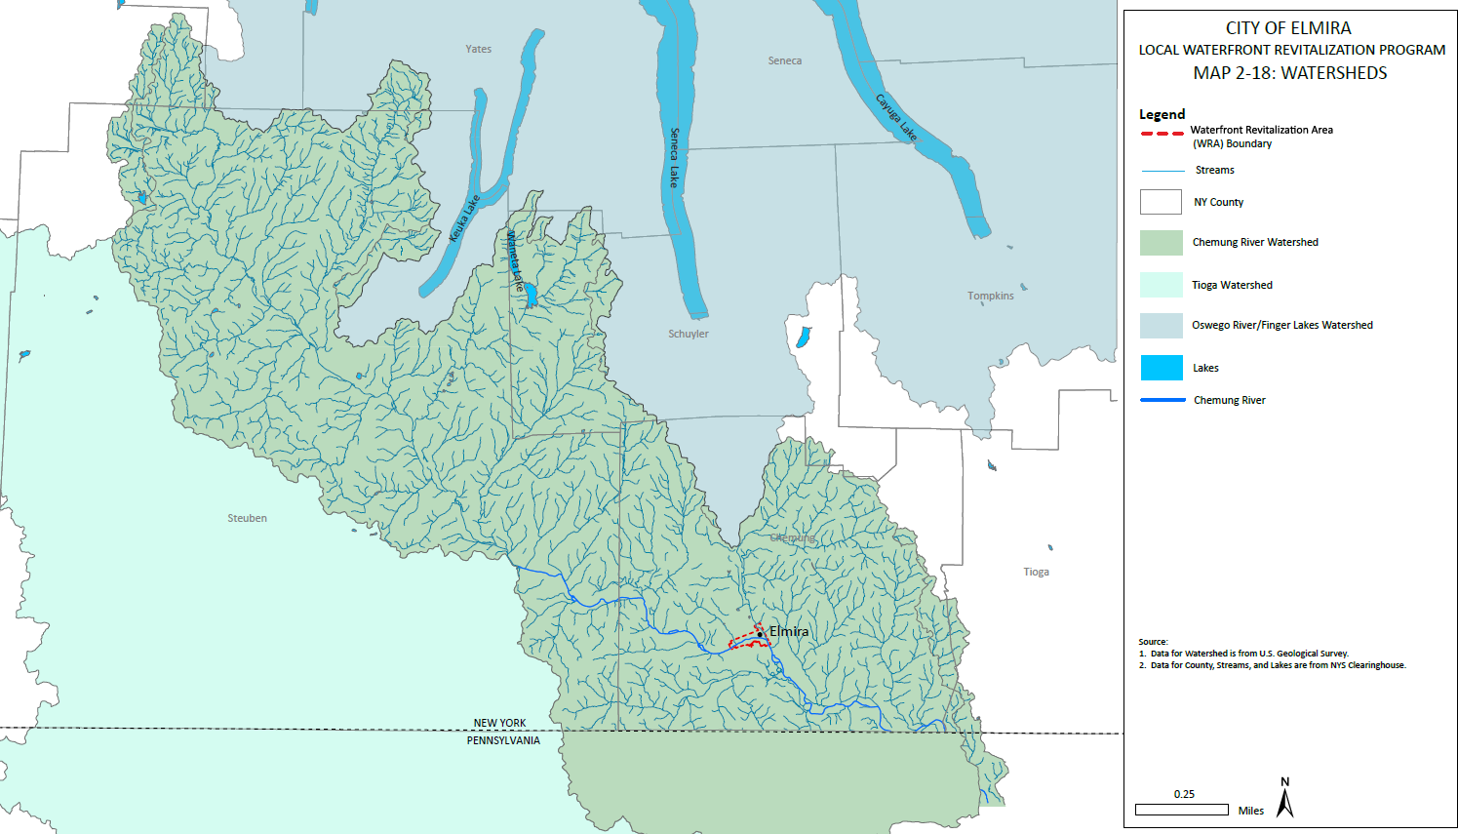
Map 2-18: Watersheds

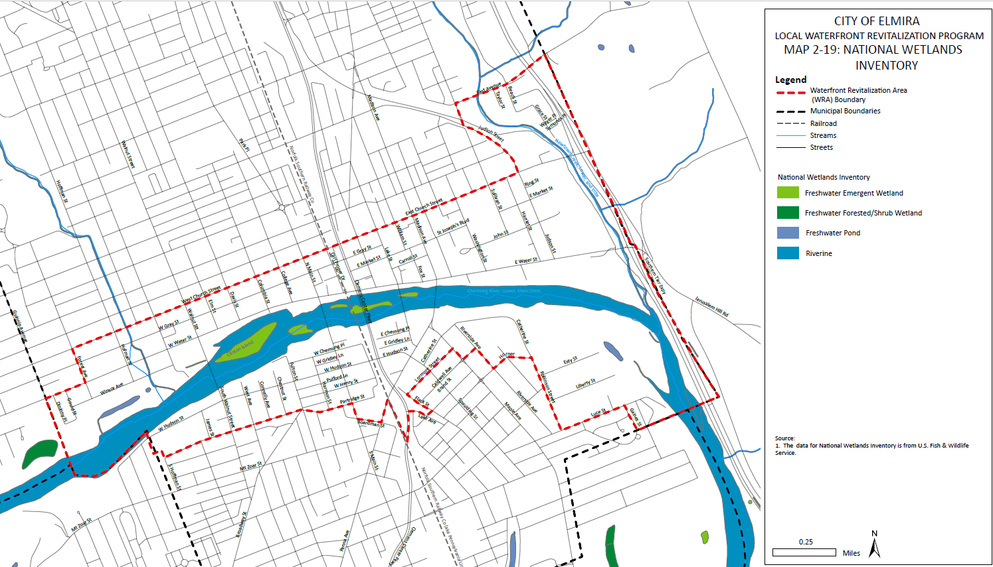
Map 2-19: Wetlands

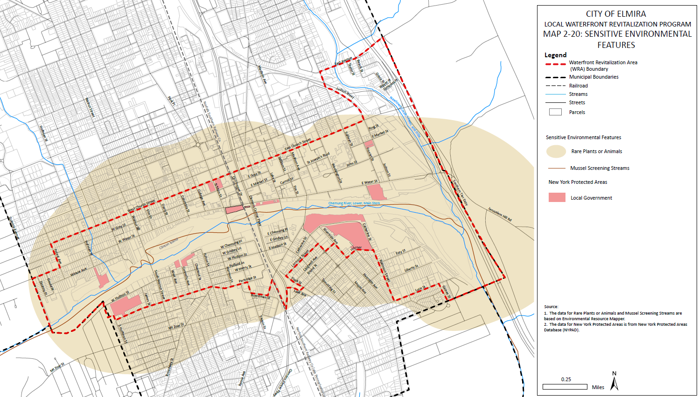
Map 2-20: Sensitive Environmental Features

Table 2-8: Bird Species
Bird Species | Breeding Season Dates
Bald Eagle | 9/1-8/31
Black-billed Cuckoo | 5/15-10/10
Black-Capped Chickadee | 4/10-7/31
Bobolink | 5/20-7/31
Canada Warbler | 5/20-8/10
Chimney Swift | 3/15-8/25
Golden Eagle | Breeds Elsewhere
Golden-winged Warbler | 5/1-7/20
North Saw-whet Owl | 3/1-7/31
Prairie Warbler | 5/1-7/31
Prothonotary Warbler | 4/1-7/31
Rusty Blackbird | Breeds Elsewhere
Wood Thrush | 5/10-8/31

Rare or Endangered species or natural communities:
The NYSDEC and the Western New York Land Conservancy (WNYLC) maintain an inventory of threatened and endangered species, habitats, and natural communities referred to as the New York Natural Heritage Program. Endangered, threatened, and special concern species found in the Elmira region are listed below:
Table 2-9: Rare or Endangered Species
Species | Classification | Status
Northern Long Eared Bat | Mammal | Endangered
Green Floater | Mollusk | Proposed Threatened
Monarch Butterfly | Insect | Candidate

Invasive Species:
Invasive species are qualified as any plant or animal species that lives in a region that are not native to the area or region. These species are often an environmental concern as they create higher levels of competition with existing regional species and can cause ripple effects throughout the ecosystem that they invade. Below is a list of invasive species identified within the project boundary.

Table 2-10: Invasive Species
Fish/Aquatic | Plants | Insects/animals
Common Carp | Flowering Rush | (Asian) Jumping worms
Asian Clam | Tree-of-Haven, Ailanthus
Green Sunfish | Japanese Knotweed,  Japanese Bamboo
 | Knotweed

Fish and aquatic species are found in water bodies throughout the WRA and may out compete native and endangered species. Invasive plants around found throughout the WRA. In particular, knotweeds are found along waterbodies and shore lines. The Tree of Haven is the known preferred habitat for the spotted lanternfly. According to the Cornell College of Agriculture and Life Science (CALS), Spotted Lanternfly have been spotted in Chemung County, though an infestation is not currently present. Infestations are present in neighboring Tioga and Tompkins County, and a Protective Zone has been established by NYSDEC.

D. Visual and Air Quality

Air Quality Maintenance Areas, including EPA Nonattainment Areas for Criteria Pollutants:
There are no Maintenance Areas or EPA Nonattainment areas for Criteria Pollutants in the WRA. Additionally, there are no ScenicAreas of Statewide Significance (SASS) present withing the WRA.

Important waterfront views
Much of the views of the Chemung River are obstructed by flood control levees and floodwalls. Many of the walls obstruct the view of the river entirely from ground level. This has led to a somewhat negative and false image of the river. This negative image contradicts the attractive and valuable resource that the river truly is to the community. It is paramount for the revitalization of the WRA that opportunities to view the river in a positive manner are created.
Despite views of the river blocked from the shore, additional viewing opportunities exist at elevated points. This includes the Lake Street Bridge, which is further detailed in Section 2.6-C: Tourism Resources. While not within the WRA, views of the WRA and the Chemung River can be seen from Jerusalem Hill.

2.5 Flooding and Erosion

A. Floodplains
Due to the relatively flat area bordering the Chemung River, surrounded by steep hillsides, much of the Elmira region is classified as a floodplain. The City of Elmira has a long history of flooding, with the St. Anges Flood in 1972 solidifying the legacy of flooding in the community and continuing to impact the WRA to this day. As such, it is integral to assess floodplains within the WRA to ensure any proposed improvements will not have an adverse effect on the surrounding area or increase flooding impacts. Future development within floodplains should be in accordance with existing building codes, which are further detailed in Section V Techniques for Local Implementation of the Program. For any structures that are present beyond the flood protective structures, such as bridges and piers, care should be taken to protect these structures from the impacts of flooding.
Despite this history, floodwaters have been controlled within the WRA, mostly due to flood protective features such as levees and flood walls. As such, flooding on the scale of the 1972 Agnes Flood has been minimized, but according to 1997 FEMA flood mapping, much of the WRA is still susceptible to flooding. These maps are in the process of being updated by FEMA to reflect current flooding conditions.

Floodplain Map
There are multiple flood zones located within the WRA, categorized by FEMA as X and AE. Flood zone categories differentiate flood risk levels in any given region. Flood zone X is a moderate-risk area, with less than a 1% chance of annual flooding. Zone AE is a high-risk area where there is a 1% chance of annual flooding or greater. Over 30 years, there is a 26% chance of flooding in zone AE. Flood insurance is mandatory for any structures within zone AE, but is not mandatory for flood zone X.
The majority of the WRA protected by flood levees. A portion of the WRA north of the Chemung River between Sullivan and Judson Streets is located in the floodplain. It is noted that none of the WRA is in the 500-year floodplain.

B. Levee Inventory
There are 50 floodwalls surrounding the Chemung River within the City of Elmira and multiple embankment. These were constructed and expanded between the 1930s and 1970s to combat recurring flooding from the river. These levees are at risk of losing their FEMA accreditation, which may increase the portion of the WRA in the floodplain. The north and south levee systems are detailed below.
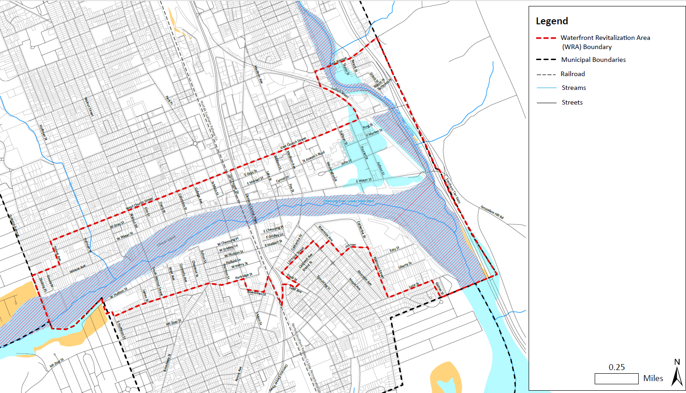
Map 2-21: Floodplains
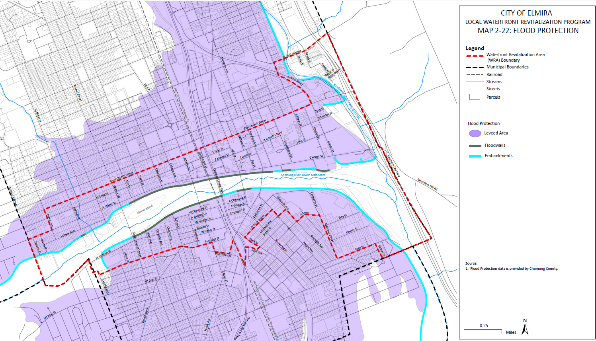
Map 2-22: Flood Protection

North Elmira Levee System:
This levee system was authorized under the Flood Control Act of 1936 and later modified by the Flood Control Act of 1938. It consists of 29,000 feet of earth levees, 6,800 feet of concrete walls, and multiple appurtenant drainage structures along the river. The average levee height is 6 feet across the complete length of 6.431 miles. These improvements were designed and installed to protect the City of Elmira from flood discharges on the Chemung River and Newtown Creek. Project operations for the Northern Levee System were completed in 1949 and later repaired in 1976 after a period of flooding, with updates to the system occurring alongside repairs. Last assessed in 2021, this system consists of the following:
- 34 Alignment Lines
- 24 Embankments
- 114 Floodwalls
- 6 Closed Structures
- 54 Pipes
- 35 Pipe Gates
- 23 Relief Wells
- 1 Pump Station
- 7 Piezometers
- 24 critical structures behind this levee, including broadcast communications posts, college/university campuses, and correctional facilities.
Damage from flooding occurred in June of 1972, when Tropical Storm Agnes produced a flood exceeding all records to date. Peak flow on the Chemung River reached over 200,000 cubic feet per second, according to estimates from the USGS. During this storm, existing leveed areas were overrun and suffered heavy damage. In 1975 there, a less severe flood negatively impacted the already damaged system, resulting in the urgent need for repairs.

South Elmira Levee System:
This levee system was authorized under the Flood Control Act of 1936 and later modified by the Flood Control Act of 1938. It consists of 32,000 feet of earth levees, 4,500 feet of concrete walls, one pumping station located at Brandt Park, and multiple appurtenant drainage structures along the river. These improvements were designed and installed to protect the City of Elmira from flood discharges and conditions similar or approximately equal to those experienced during May of 1946. Two major modifications were made to enhance the levee system after construction. The first improvement included the addition of relief wells and a pump station in Brand Park, downstream from Madison Avenue. The second modification featured the incorporation of a portion of the Seely Creek levee (upstream) into Clemens Center Parkway during a 2000s highway construction project. Initially constructed in 1976 and last assessed in 2018, the average levee height in this system is 5ft, and the total length of levee is 6.857 miles.

This leveed area consists of the following:
- 14 Alignment Areas
- 7 Embankments
- 54 Floodwalls
- 3 Closed Structures
- 39 Pipes
- 11 Pipe Gates
- 42 Relief Wells
- 1 Pump Station
- 1 Piezometer
- 20 critical structures behind this levee, including 2 Emergency Medical Service stations, 5 electric substation facilities, 2 Emergency Service Fire Stations, and 1 law enforcement station.
For both the North and South Elmira Levee system, additional flood storage is available at Almond Lake, Tioga-Hammond Lakes, Arkport Dam, and Cowanesque Lake. Together these bodies of water control 36% of the drainage area upstream from Elmira.

Risk of Exceedance:
The Levee Safety Senior Oversight Group (LSOG) considers the risk associated with the Elmira Levee to be low (LSAC 4), with overtopping breach as the primary risk driver. According to the U.S. Army Corps of Engineers, the likelihood of overtopping for the levee segment is 1 in 500 with moderate potential for loss of life, assuming a population of 15,000 people in the leveed area and potential inundation depth anticipated at a 4ft maximum. An emergency action plan is in place for the levee. Due to the most recent major flood occurring over 35 years ago, an emergency action plan is vital as the local residents may be unaware of potential flood risks in their community. Relief wells were added following Tropical Storm Agnes and the major flood of 1972, but due to a lack of severe flooding, these have not been tested under a full flood load.

2.6 Historic and Cultural Resources
The WRA has played an important role in a large part New York State and the United States’ history, from indigenous settlements, the Revolutionary War, and the Abolition Movement, to the Industrial Revolution. The WRA also has a piece in literary history, as many of the writings of American author Mark Twain were penned at Quarry Farm, less than a mile northeast of the WRA. Additionally, the WRA contains a vast array of important architecture dating to the 19th and early 20th centuries in the natural setting of the Chemung River Valley. This legacy has resulted in a variety of important scenic, cultural, and historic resources located in or near the WRA.
Though there are no federal or state recognized territories or tribal lands, the WRA is located in the ancestral territory of the Onöndowa’ga:’ (Seneca) Nation, a member of the Haudenosaunee Confederacy, as well as the Susquehannock people. Additionally, there are no heritage areas or corridors within the WRA.

A. Designated Scenic Resources
There are no designated scenic resources in the WRA, though the WRA is not lacking in scenic value. The centerpiece of the WRA, the Chemung River, provides a variety of scenic vistas as it carves through the Chemung River Valley. The WRA has unique viewing opportunities as one of the only urban settings along the Chemung River, providing visitors and residents alike the unique opportunity to view the Chemung River and its palisades, wetlands, natural habitats and flora and fauna from bridges, buildings, and other viewing vantage points. In particular, scenic views are available from the WRA’s five bridges, including the Lake Street bridge which has dedicated pedestrian viewing areas of the Chemung River.

B. Designated Historic Resources
The WRA is home to a wide range of important historic resources, particularly pre-1900 and turn of the 20th century architecture. Within the WRA, there are seven (7) historic districts containing 416 contributing buildings, which includes both listed and eligible buildings, as well as eight (8) individually listed buildings, some of which are contributing buildings to the historic district. While much of the historic integrity of the WRA has been preserved, the 1972 Agnes flood, urban renewal practices, and economic decline have led to the loss of many historic buildings. This includes the loss of several contributing and designated historic buildings such as 102-116 West Water Street, 106-114 Columbia Street, and115 Columbia Street.
Table 2-11: Natural Register of Historic Places

Property Name | Area of Significance | Description
Brand, John, Jr., House | Architecture | A large historic property located in the Maple Ave Historic District
Brand, John, Sr., House | Architecture | A large historic property located in the Maple Ave Historic District
Chemung Canal Bank Building | Commerce, Architecture | Originally home to the Chemung Canal Bank, now Chemung Canal Trust Company and is believes to be the oldest surviving commercial building the City of Elmira
Erste Deutsche Evangelische Kirche | Architecture | Large ornate church in Downtown Elmira
Eustace, Alexander, House | Politics/ Government, Architecture | A large historic property located in the Maple Ave Historic District
Howell, F. M., and Company | Industry | Historic manufacturing facility
Miller Block and Townhouse | Commerce, Architecture | Intact commercial building
Park Church | Architecture, Religion, Social History | Large ornate church in Downtown Elmira

As previously indicated, seven (7) Historic Districts are present within the WRA, including five primary districts and two “boundary increases.” These districts, with the exception of the Maple Avenue Historic District, are located on the north side of the Chemung River. These districts are important because of their intact architectural character, with profound examples of Queen Anne, Italianate, Colonial Revival, Prairie, and Modernist architecture. These styles are an important tie to the history of the City of Elmira and have been preserved accordingly. The Historic Districts are briefly described below.

Chemung County Courthouse Complex
The Chemung County Courthouse Complex consists of four buildings that continue to be used as the primary courthouse and supporting facilities for the County of Chemung. The Complex was built between 1836 and 1899 and features four, two-story buildings and a three-story bell tower. The complex was built in classical and Italianate styles, symbolic of the prevailing architectural styles of the WRA during this period.

Near Westside Historic District and Near Westside Historic District Boundary Increase
The Near Westside Historic District consists of 492 contributing buildings, 315 of which are in the WRA, ranging in year of construction from the 19th century to the 1950s and beyond. The district is largely intact and features primarily Italianate and Colonial Revival architecture, as well as important examples of Art Deco and Modernist architecture. The district is a tourism resource as well, providing self-guided walking tours of important structures.

North Main and West Water Street Commercial Historic District and North Main and West Water Street Commercial Historic District Boundary Increase
As some of the earliest streets in the City of Elmira, this area was one of Elmira’s first retail corridors. While many of the original buildings in the district no longer exist, the remaining architecture represents an important resource that preserves the character of the shopping district. Contributing buildings include architecture from the Civil War era to the 1950s Art Deco period.

Elmira Civic Historic District
The Elmira Civic Historic District consists of 35 contributing buildings, 29 of which are in the WRA, including the Chemung County Complex and additional civic structures built for Chemung County, educational facilities, social and commercial buildings. Lake Street and East Church Street, which make up the core of the district, feature distinctive architecture dating back to 1836. The district is one of the largest intact collections of commercial and institutional buildings within the WRA, and the City of Elmira has shown promising revitalization and adaptive reuse in recent years.

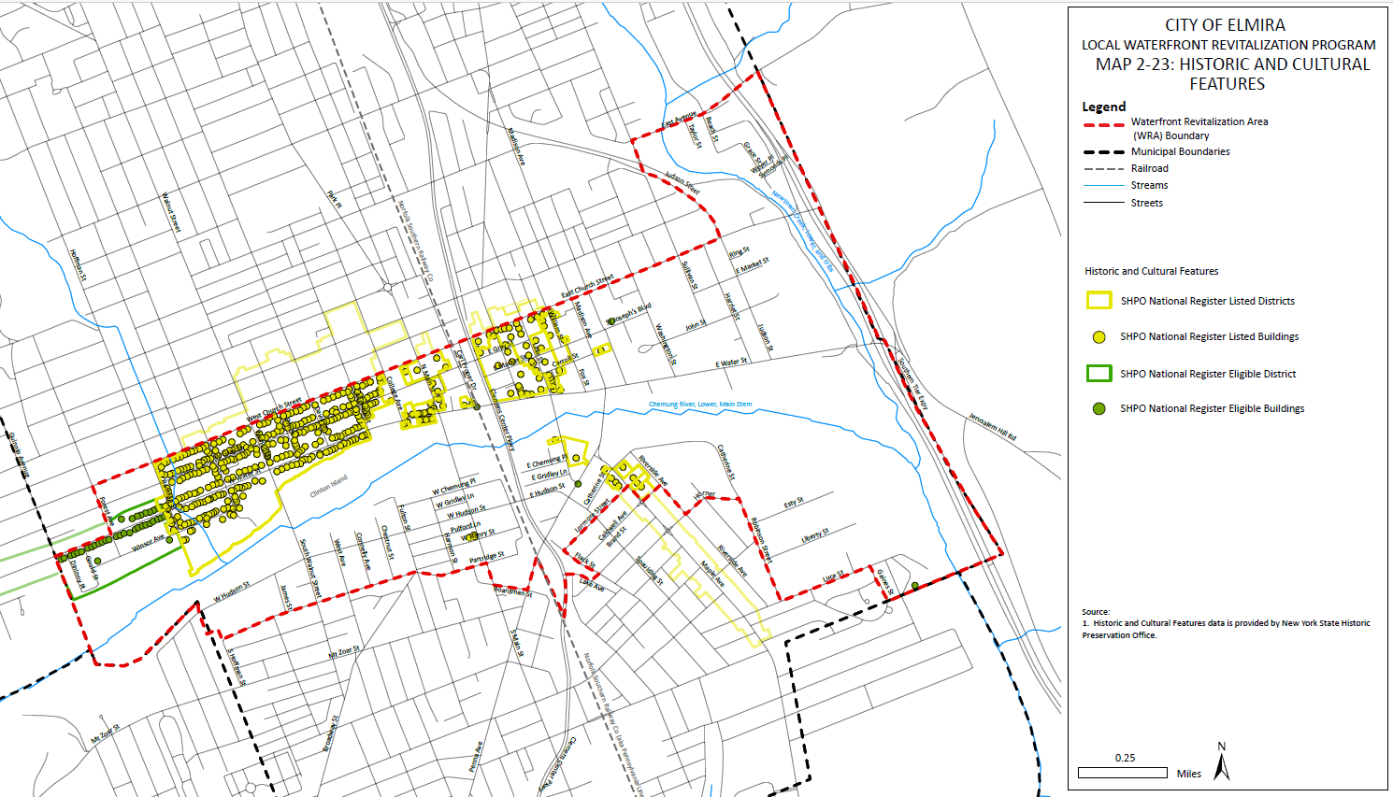
Map 2-23: Historic and Cultural Features

Maple Ave Historic District
The Maple Ave Historic District is a collection of well-preserved upper-class estates and middle-class homes along Maple Avenue south of the Chemung River. The district includes important examples of Italianate, Second Empire, Queen Anne, Stick/Eastlake, Shingle Style, Italian Renaissance, Prairie School, and Craftsman architecture. The street, once a suburban retreat for the city’s elite, was absorbed by the city as it expanded and continues to be an important collection of late nineteenth and early twentieth century residential architecture.

C. Tourism resources

Hotels
There is one hotel in the WRA, the Clarion Inn. The hotel is located on the eastern portion of the WRA, between East Water Street and the Chemung River, and features an onsite restaurant and banquet facilities. Additional lodging facilities are mainly located north of the WRA in the town of Horseheads.

Entertainment Venues
There are three major entertainment venues located in the WRA: First Arena, the Clemens Center, and Dunn Field. Both the Clemens Center and First Arena are located in the northern portion of the WRA in Downtown Elmira. First Arena, built in 2000, is the area’s largest entertainment venue with a capacity of 3,784 seats in its normal configuration. The Arena is a keystone for the WRA, the City of Elmira, and the region for major events, including concerts, professional sports such as ice hockey and lacrosse, vendor expos, and a variety of other events. The Clemens Center has a capacity of 1,618 and offers a large stage and supporting facilities for theatrical events, musical performances, and lectures. The facility frequently hosts musical theatre shows, comedy shows, dance performances, and musical events. Dunn Field, located in the southern portion of the WRA, is an outdoor baseball field with a seating capacity of 4,020. Opened in 1939, the facility is the oldest entertainment venue in the WRA, hosting games for the past 85 years. All three facilities are located within close proximity to the Chemung River and with a combined seating capacity of 9,422, are responsible for bringing thousands of visitors to Downtown Elmira and the waterfront.

Festivals
Numerous major festivals, including the Taste of Downtown, Alive After Five, Muralfest, and Street Painting, take place within the WRA. The Taste of Downtown is an annual festival that brings vendors from across the region to the Arnot Art Museum. The events highlight the local restaurants, breweries, cultural resources and activities of Downtown Elmira and portions of the WRA. Alive After Five is a bi-weekly summer festival that brings free live music to various locations throughout the WRA. Both events host thousands of visitors from the region and beyond into the WRA.

Museums
Two museums are located within the WRA, the Arnot Art Museum and the Chemung County History Museum. The Arnot Art Museum displays a permanent collection of Americana and European Art from the seventeenth to twentieth century. The Chemung History Museum is an important resource that displays a variety of local heritage, including exhibits about author Mark Twain.

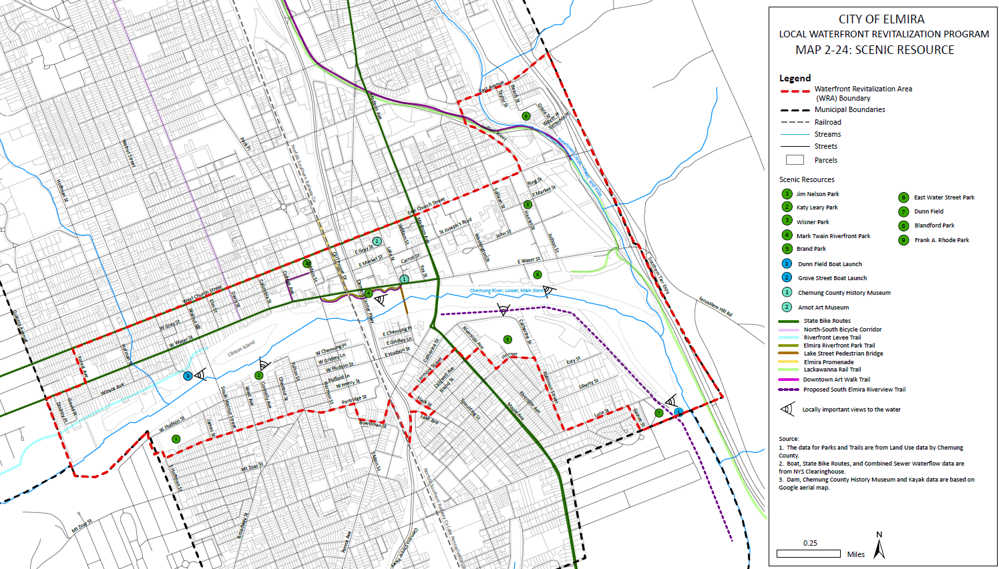
Map 2-24: Scenic Resources

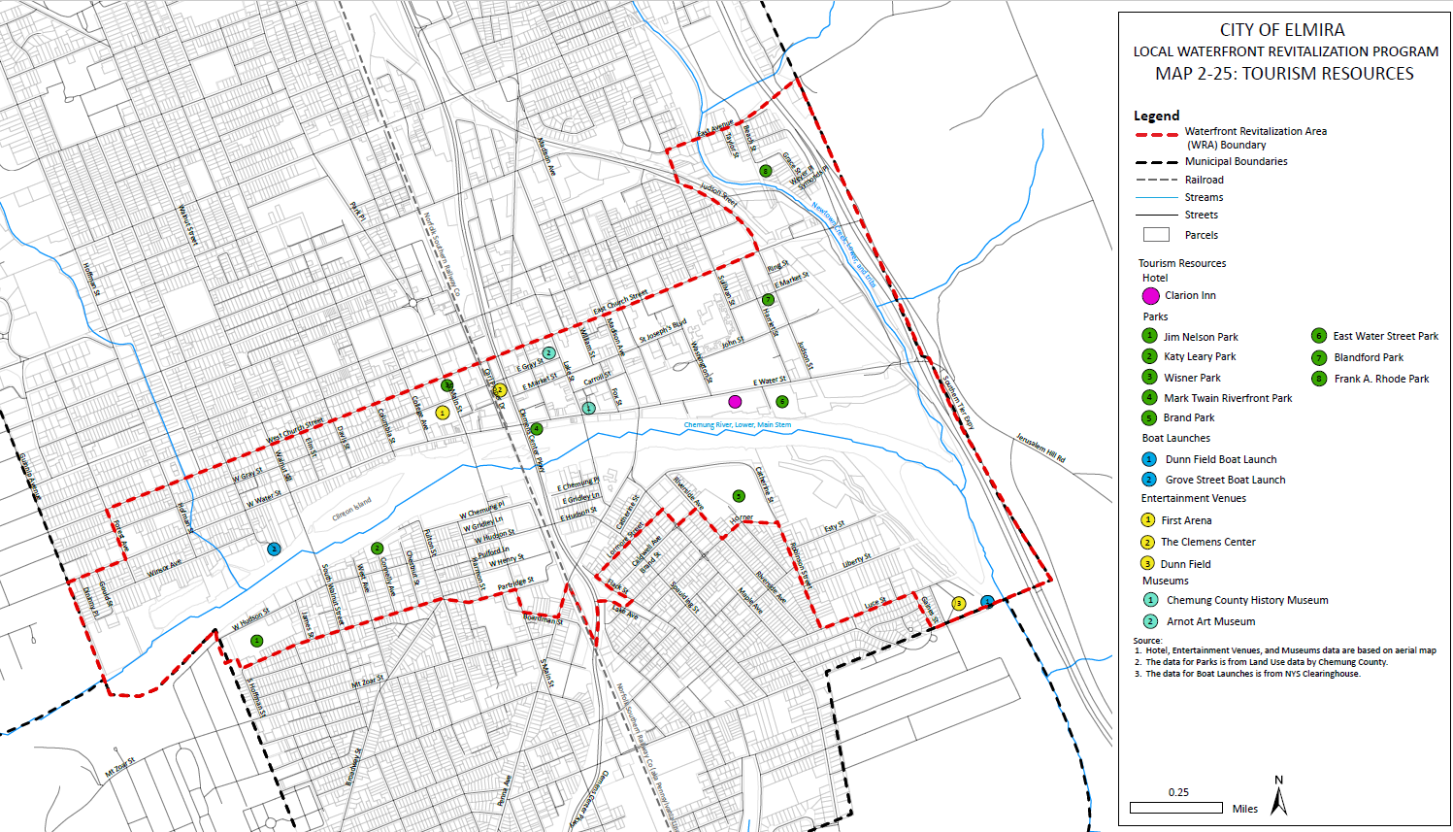
Map 2-25 - Tourism Resources

Outdoor Recreation
Outdoor recreational spaces are an important resource in the WRA, and include seven (7) parks and two (2) boat launches. Parks within the WRA provide a variety of recreational facilities, including baseball and sports fields, skateparks, playgrounds, pavilions, public grilling stations, community gardening space, and scenic viewpoints of the Chemung River. Two notable parks, the Mark Twain Riverfront Park and Brand Park, are feature parks for the city, and have a variety of recent or planned upgrades. Additionally, these parks provide opportunities to increase viewing opportunities of the Chemung River and create active recreation opportunities on and adjacent to the River.
The Chase-Hibbard dam splits the river into an upstream and downstream portion which makes recreational navigation difficult and potentially dangerous, though recreation portage routes are marked along the south shore of the Chemung River around the dam. The Grove Street Boat Launch is located in the western edge of the WRA and provides access to the river upstream of the low head dam for kayaks, canoes, and small motorboats. The Dunn Field Boat Launch is located in the southern portion of the WRA and provides access to the Chemung River downstream of the dam. Both facilities have a concrete boat ramp, trailer parking, and accessible fishing sites.
Additional recreational spaces include the former Water Street Bridge, which has been converted into a pedestrian bridge over the Chemung River. The bridge provides unique viewing opportunities of the Chemung River, Downtown Elmira, and the entirety of the Chemung River Valley. The bridge is a key linkage between the northern and southern portions of the WRA for pedestrians and cyclists.

Trails
There are three trails within the WRA: the Downtown Art Walk, the Lackawanna Rail Trail, and the Riverfront Levee Trail.
The Riverfront Levee Trail is a multi-faceted trail with the main loop to the west and an additional offshoot route to the east down West Water Steet and through the Mark Twain Riverfront Park. Much of the trail is located on private land, which calls into question the legitimacy of the trail. Opportunities for waterfront access may be restricted if this existing trail route is utilized without extensive coordination with private landowners and NYSDEC. The five-mile main loop trail can be accessed from the east at the #21 Grove Street Boat Launch located at 36 Grove Street or from the West at Pirozzolo Park at 1255 West Water Street. The “loop” is comprised of two trails, the Riverfront Levee Trail on the north/inland side, and the River’s Edge Loop Trail on the south/river side. The Riverfront Levee Trail loop is a grass trail for walking, jogging, cycling, cross-country skiing, snowshoeing, and more situated on both private and public lands. To the west, the trail ends at the Walnut Street Bridge but continues “off trail” along the sidewalk of West Water Street until it meets the Mark Twain Riverfront Park where the trail officially starts again and meanders through the park. The portion of the trail that runs through the Mark Twain riverfront park is a paved path. Opportunities for acquisition either in fee or through an easement should be explored in the future as part of this LWRP or explore locating the trail on publicly owned assets.
The Lackawanna Rail Trail is an 8.5-mile-long paved trail that runs on the former Erie-Lackawanna Railroad bed. Within the WRA, the trail runs parallel to the west bank of Newtown Creek, crossing over the creek near the confluence of Newtown Creek and continuing parallel to the east bank of

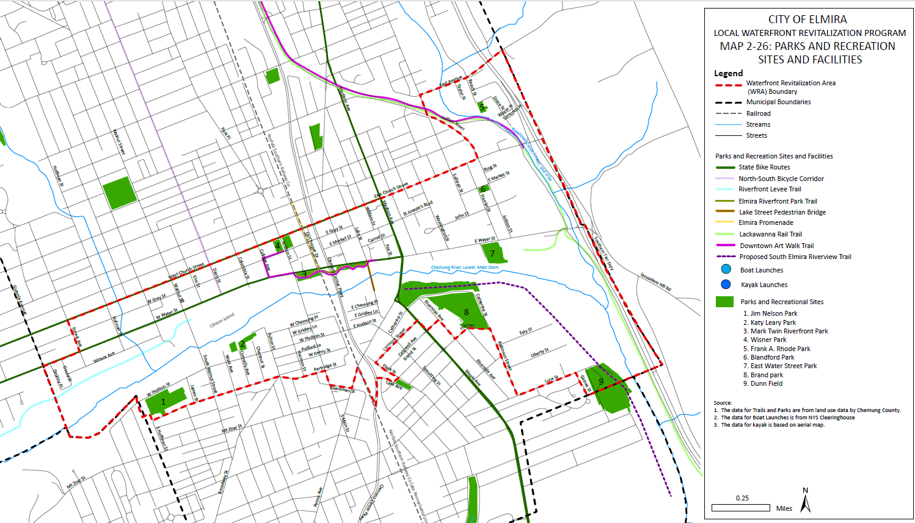
Map 2-26: Park and Recreation

the Chemung River. Trail access and parking are free and offer great conditions for walking, jogging, cycling, cross-country skiing, snowshoeing, and more. Parking is available at Eldridge Park and the Elmira city-owned parking lot on East Water Street. The trail is generally level and includes occasional benches and bike racks. The trail property is owned by the New York State Department of Transportation (NYSDOT), but the City of Elmira maintains the western section of the trail and Chemung County maintains the eastern section. The eastern section (begins at East Water Street in Elmira) runs along the Chemung River, providing waterfront views while encouraging riverfront access. It also passes through wooded areas and small meadows..
The Downtown Art Walk is a self-guided walking tour of Downtown Elmira along existing streets and trails, with locations of local street art and architecture within the WRA, including locations along the Chemung River. While it is difficult to view the Chemung River from the Art Walk, it presents opportunities to increase awareness of the Chemung River and potentially collocate art installations in conjunction with river viewings. The art walk was created in 2014 through a partnership with the City of Elmira and Elmira POP Art.
Two statewide bike routes, Bike Routes 17 & 14, are within the WRA and meet in the City of Elmira. Biek Route 14 follows Madson Anue and Maple Avenue in the WRA. Bike Route 17 follows E/W Water Street and E/W church street to Madison Avenue, and then continue to Maple Avenue in The WRA. Both route cross the Chemung River on the Madison Avenue bridge, though neither route encourages waterfront access in the WRA. They are mapped and signed by the NYS Department of Transportation (NYSDOT) as they run on or parallel to major state highway corridors. Combined, it is one of many long-distance bicycle touring routes identified by the department.

D. Archaeological Resources, including shipwrecks and historic dry docks
The majority of the WRA is located within archeological buffer areas, according to the New York State Historic Preservation Office (SHPO) Cultural Resources Information System (CRIS). These buffer areas represent a specified distance around known archaeological sites that SHPO has previously inventoried. Given that these buffer areas are only based on proximity to sites, specific locations within these areas may not be archaeologically sensitive, and locations outside of these areas may still be archaeologically sensitive. For future projects that may be proposed within the WRA, SHPO’s Archaeology Unit would evaluate archaeological sensitivity based on a variety of environmental factors, including topography and hydrology to determine the potential for impacts on archaeological resources. In instances where the evaluation indicates the potential for impacts to archaeological sites, a cultural resources investigation may be warranted which may include historic research and shovel testing to determine if archaeological resources are present.
As the Chemung River is not navigable, there are no dry docks or historic underwater archaeology located in the WRA. SHPO routinely reviews state and federally funded dredging and other underwater projects to determine if significant archeological sites are likely to be impacted and, when appropriate, to develop appropriate avoidance or mitigation measures based on SHPO guidance. For future projects that may be proposed within or adjacent to the Chemung River, SHPO’s Archaeology Unit would evaluate archaeological sensitivity to determine the potential for impacts on underwater archaeological resources.

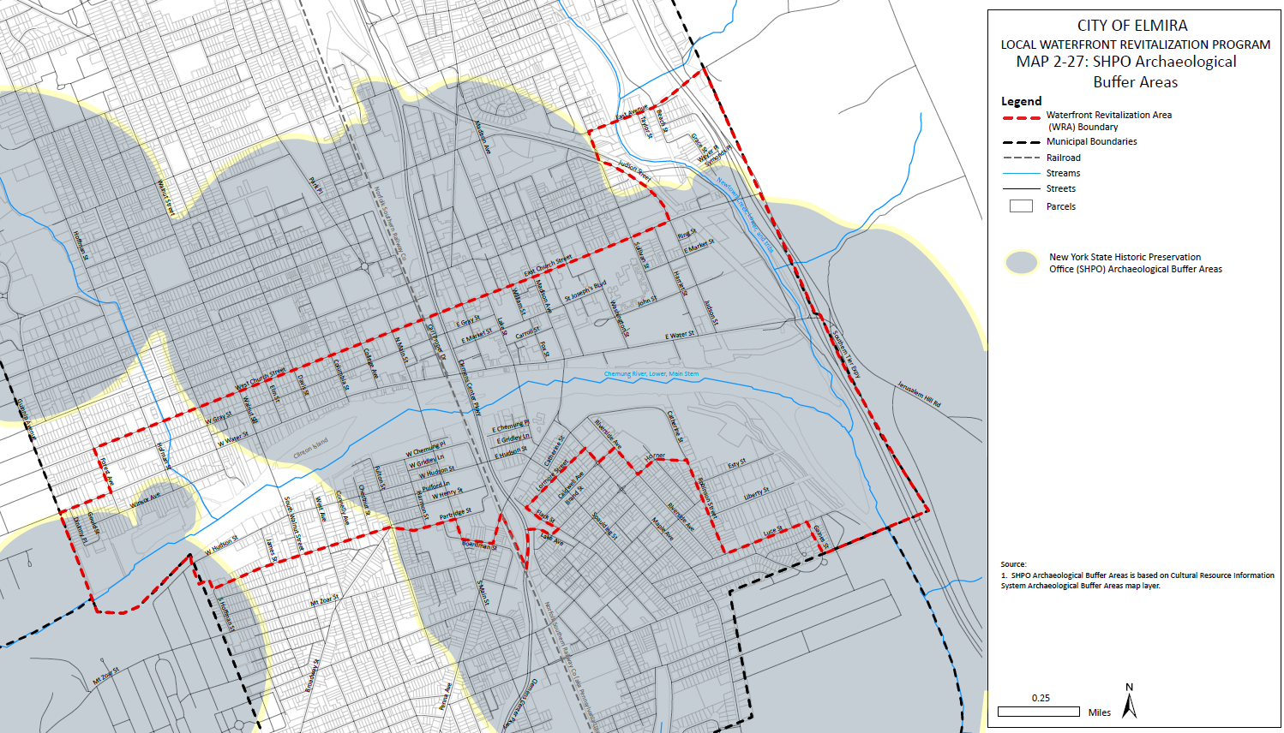
Map 2-27: SHPO Archaeological Buffer Areas

§ 70-0118. Disproportionate impacts on disadvantaged communities.

